APPEAL

FOR : | - Klimaatzaak ASBL, with registered office at rue Joseph II 20, 1070 Brussels, registered with the ECB under number 0567.926.684,  - All persons who are listed in Appendix A attached to the citation,  Appellants ;  all with advice from  - Maîtres Carole M. BILLIET (carole.billiet@equal-partners.eu), Luc DEPRÉ  (luc.depre@equal-partners.eu), Audrey BAEYENS  (audrey.baeyens@equal-partners.eu), Linli-Sophie PAN-VAN DE MEULEBROEKE (Linli.PanVandeMeulebroeke@equal-partners.eu), Camille DE BUEGER (camille.debueger@equal-partners.eu) and Gautier ROLLAND (gautier.rolland@equal-partners.eu), whose offices are at Place Flagey, 18, 1050 Brussels, and  - Mr. Roger H. J. COX ( r.cox@paulussen.nl ) , whose office is established  Sint-Pieterskade 26B, 6212 AD Maastricht, The Netherlands,  electing all domicile in this cause at the office of Equal Partners, in 1050 Brussels, Place Flagey, 18.
AGAINST: | 1. The Belgian State, represented by its Government in the person of the Minister for Climate, Environment, Sustainable Development and the Green Deal, whose offices are located at 1000 Brussels, Boulevard du Jardin Botanique, 50 (FINTO), bte 51,
 | First Respondent ;
 | with the advice of
- Nathalie VAN DAMME, lawyer, whose office is located at 4020 LIEGE 2, Place des Nations Unies 7 a ;
- Maîtres Guy BLOCK and Kris WAUTERS, lawyers, whose office is located at 1050 Chaussée de La Hulpe 187 ;

- The Walloon Region, represented by its Government in the person of the Minister for Climate, Energy and Mobility, whose offices are established at 5000 Namur, rue d'Harscamp 22, Second Respondent ;
represented by Pierre MOËRYNCK, lawyer, 1040 Brussels, avenue de Tervueren, 34/27;

- The Flemish Region, represented by the Flemish Government in the person of the Flemish Minister for Justice and Maintenance, the Environment, Energy and Tourism, whose offices are established at Boulevard du Roi Albert II, 7, 1210 Brussels, Third respondent;
represented by Mr Steve RONSE, lawyer, whose office is located at 8500 Kortrijk, Beneluxpark, 27B;

- The Brussels-Capital Region, represented by its Government in the person of the Minister of the Government of the Brussels-Capital Region, responsible for Climate Transition, the Environment, Energy and Participatory Democracy, whose office is established in 1210 Brussels, Boulevard Saint-Lazare 10, Fourth party respondent ;
represented by Ivan-Serge BROUHNS and Guillaume POSSOZ, lawyers, established in 1170 Brussels, chaussée de la Hulpe, 185.

Judgement undertaken
The judgment of 17 June 2021 (R.G. 2015/4585/A) by the Fourth^{e} Chamber of the French-speaking Court of First Instance of Brussels, Civil Section (hereinafter "the judgment of 17 June 2021" or "the judgment under appeal").

Court of Appeal
The [_______] Chamber of the Court of Appeal of Brussels

Place of appearance
At the said Brussels Court of Appeal, 1000 Brussels, Place Poelaert 1, sitting in its usual place of business [__________________].

Date of appearance
On [______________________] at [___________] hours

General roll number
R.G. [________________________]

Table of Contents
- As a preliminary matter .................................................................................................................5
- Statement of Basic Facts: Part I .............................................................................8
Global warming: the inadequacy and insufficiency of the binding obligations imposed on Belgium by 2020 .........................................................................................................8
The common thread: knowledge of the danger and the measures to be taken to prevent or limit it 8
II.1.1 The IPCC as an undisputed scientific reference, recognized by the
international community ......................................................................................................... 8 II.1.2 Global warming and CO ₂....................................................................... 12
II.1.3 The key concept: dangerous global warming ............................................. 20
II.1.4 The carbon budget: the GHG emission reductions required to avoid the
dangerous global warming ........................................................................................ 22
Respondents' explicit recognition of the need to reduce GHG emissions by at least 25% to 40% by 2020 ........................................................................................ 28
The inadequacy and insufficiency of international and European positive law standards for 2020 .......................................................................................................................................... 30
II.3.1. The objectives set by the European Union ................................................................. 31
II.3.2 The 1997 Kyoto Protocol, as amended by the 2012 Doha Amendment
33
- Statement of Basic Facts: Part II ...................................................................... 35
On the importance of a minimally linear pathway for GHG reductions ................. 35
- Statement of Basic Facts: Part III ....................................................................... 37
As for the climate emergency and the need to rule as quickly as possible on the present case 37
- Subject of the call ................................................................................................................... 38
First complaint: the emission reduction targets imposed by the standard of conduct within the meaning of Articles 2 and 8 of the ECHR and Article 1382 of the Civil Code must be determined in the light of the authorities' knowledge of the danger threatening their populations and the measures to be taken to help prevent or limit it ..................................................... 38
V.1.1 Reminder and criticism of the judgment .................................................................. 38
V.1.2 In light of the knowledge of the hazard and the measures to be taken to avoid or mitigate it, what is the standard of behaviour required of authorities under the
  - and 8 of the ECHR and Article 1382 of the Civil Code? ................................................................. 40
Second grievance: .................................................................................................................... 54
    - Reminder and criticism of the judgment .................................................................. 55
    - The applicable principles............................................................................................. 56
    - Application in this case ............................................................................................... 59 Other objections .......................................................................................................................... 61
    - The UNFCCC has not been amended by the Kyoto Protocol and the Paris Agreement; its
original wording remains unchanged .............................................................................................. 61
    - The court erred in considering that it was required to exercise only marginal control over the authorities' compliance with the standard of conduct imposed by Articles 2 and 8 of the
ECHR and by Article 1382 of the Civil Code ..................................................................................... 62
    - The court wrongly considered that mitigation and adaptation are both adequate responses to global warming and that 450 ppm of GHGs is a limit that should not be exceeded before 2100 ............................................................................................................ 63
- On call ............................................................................................................................ 65
- On costs ..................................................................................................................... 66

Device .............................................................................................................................. 67
- List of diagrams ................................................................................................................ 69
- Inventory of parts ........................................................................................................... 69

I. As a preliminary remark
- The purpose of this appeal is to partially reverse the judgment of 17 June 2021 (R.G. 2015/4585/A) by the 4th^{e} Chamber of the French-speaking Court of First Instance of Brussels, Civil Section (hereinafter "the judgment of 17 June 2021" or "the judgment under appeal").
- The judgment of 17 June 2021 rightly decided that the main claim was admissible both in respect of Klimaatzaak vzw and in respect of the co-plaintiffs mentioned in the annex (Annex A) to the summons to institute proceedings of 2 June 2015.
The judgment under appeal also rightly decided that the voluntary intervention of Mrs Inge De Vriendt and the persons mentioned in the annex to the application for voluntary intervention of 12 June 2019 (Annex B) was admissible.
It is also rightly that the judgment in question "ruled that, in pursuing their climate policy, the defendants did not behave like normally prudent and diligent authorities, which constitutes a fault within the meaning of Article 1382 of the Civil Code".
It is still rightly that the judgment of 17 June 2021 "held that, in pursuing their climate policy, the defendants infringe the fundamental rights of the plaintiffs, and more specifically Articles 2 and 8 of the ECHR, by failing to take all necessary measures to prevent the effects of climate change affecting the plaintiffs' lives and privacy".
This is clearly right. The consequences of global warming that lead to a violation of Articles 2 and 8 of the ECHR include extreme heat, extreme droughts, extreme precipitation, disruption of ecosystems such that food security is endangered, rising sea levels due to melting ice caps and glaciers, floods etc. Warming may also lead to the passing of tipping points, which implies drastic and irreversible changes in the global climate, with no chance of a return to the previous situation. As a result, the lives, well-being and living environment of all the world's inhabitants are at risk. These consequences of global warming have been occurring all over the world for years. In Belgium, too, we have been experiencing them for years, with, among other things, repeated lethal heat waves over the past few decades and, this summer, the destructive floods in Wallonia, causing deaths, enormous damage to homes and essential infrastructure, and trauma to the people who experienced the violence of these extreme weather circumstances and are now still suffering the misery.
In this respect, specifically for Belgium and its inhabitants, the judgment in question considers: "The climate projections for Belgium by 2100 indicate consequences that have already been observed (...) as well as a concrete threat to the territorial integrity of the country, and more particularly of Flanders exposed to rising sea levels, and to human and animal health. Consequently, the diplomatic consensus based on the most authoritative climate science leaves no room for doubt that a real threat of dangerous climate change exists. This threat poses a serious risk to current and future generations living in Belgium in particular that their daily lives will be profoundly disrupted. »
- On the other hand, the judgment under appeal wrongly decided to dismiss the plaintiffs "for the remainder of their claim", including first and foremost the refusal to impose the requested greenhouse gas (GHG) reductions on the defendants, on the principal ground that the separation of powers would preclude it. (1) Since GHG emission reductions are the only effective remedy for the violation of the rights of the defendants and interveners found, that refusal deprives them of an effective legal remedy. In so doing, the judgment infringes Article 13 of the European Convention on Human Rights (ECHR) and Article 9(4) of the Convention of 25 June 1998 on Access to Information, Participation in Decision-making and Access to Justice in Environmental Matters (Aarhus Convention). (2) In addition, the minimum amount of GHG emission reductions required at the national level is determined on the basis of the universally recognised limit of dangerous warming, i.e. well below 2°C and continuing to 1.5°C, and on the basis of the residual global carbon budget that this limit implies, without any margin of appreciation for the defendants. (3) Finally, by issuing such injunctions, the judge would be imposing only the goal to be achieved, while leaving the defendants entirely free to determine the means to achieve that goal.
The judgment of 17 June 2021 was also wrong to assess the obligation of conduct imposed by Articles 2 and 8 of the ECHR and by Article 1382 of the Civil Code exclusively in the light of the binding obligations of the defendants under international, European and national intra-Belgian climate law. This standard of conduct must be assessed in the light of the universally recognised limit of dangerous warming, initially understood as a limit of 2°C and subsequently understood as a limit significantly below 2°C and pursuing 1.5°C, a factual fact enshrined in December 2015 in the Paris Agreement. As this is a factual fact universally recognized by the global scientific and political community, the binding or non-binding quality of the texts in which it is enshrined is irrelevant to the resolution of the dispute in this case.
- Finally, it is always wrongly that the judgement undertaken advances:
  - that the United Nations Framework Convention on Climate Change (UNFCCC) (1992) has been amended by the Kyoto Protocol (2007) and the Paris Agreement (2015);
  - that the court exercises marginal control over the compliance of public authorities with Articles 2 and 8 of the ECHR and the standard of conduct imposed by Article 1382 of the Civil Code; and
  - that mitigation and adaptation are two adequate responses to global warming and that a concentration of 450ppm of GHGs cannot be exceeded before 2100.

II. Statement of basic facts: part one
Global warming: the inadequacy and insufficiency of the binding obligations imposed on Belgium by 2020
- This first part of the presentation of the essential facts of the case focuses, firstly, on the red thread of scientific knowledge (1) of the danger posed by global warming and (2) of the measures to be taken to prevent or limit it. This scientific knowledge, which is an undisputed and unquestioned reference within the international community, has played a major role in the development of policies to combat global warming. A statement of this scientific knowledge is crucial since it forms the basis of the standard of care that is imposed on the Respondents.
- Secondly, it will be shown that Belgium has explicitly recognised, on numerous occasions, the need to reduce GHG emissions by at least 25% to 40% by 2020 in order to avoid a global warming of 2°C.
- In the third part, the concluding remarks will put the norms of positive law (international and European) in their context, in order to highlight their total inadequacy and insufficiency with regard to scientific knowledge and the international consensus on this knowledge.
- For the rest, the Respondents refer to the chronological statement of facts established by the Court of First Instance, on pages 6 to 42 of the judgment under appeal, with the exception of the points contradicted in the objections. The Respondents also refer to the statement of facts contained in their summary submissions of 16 December 2019, which they attach as an exhibit to this application, specifically at pages 27 to 182, nos. 25 to 337.
The common thread: knowledge of the danger and the measures to be taken to prevent it or
limit it
II.1.1 The IPCC as an indisputable scientific reference, recognised by the international community
A. The IPCC
- The Intergovernmental Panel on Climate Change (IPCC) is an intergovernmental organization established in 1988 by the World Meteorological Organization (WMO) and the United Nations Environment Programme (UNEP), which reviews and assesses the latest scientific, technical and socio-economic data from around the world relevant to understanding climate change.
- The IPCC is open to all Member countries of the United Nations and the WMO, and currently has 195 Member countries, including Belgium. It meets at least once a year in plenary sessions at which governments are represented and at which major decisions on the organization's work programme are taken, and the members and chair of the Bureau are elected. Government representatives also participate in the outline of the reports that the IPCC prepares, in the appointment of authors of these reports and in the review process of reports under preparation, and they accept, adopt and approve the reports at plenary sessions.
The importance of the role of government representatives is reflected in a document entitled "Principles for the Work of the IPCC", which includes the following principles.
Principle 3e provides as follows:
"The review process is of paramount importance to the work of the IPCC. As the Panel is an intergovernmental body, its documents must be subject to scientific peer review and government review.
Principle 4e dictates that major decisions of the IPCC are taken at plenary meetings. Principle 11efurther states that:
"Until accepted by the full Panel, the conclusions reached by the IPCC working groups and any task forces do not represent the official view of the IPCC.
- The IPCC calls itself "the leading international body for assessing climate change". This status is confirmed in that the 195 Member countries take (or at least should take) the IPCC reports as a starting point for their climate policy and that the IPCC reports have a special place in the 1992 UNFCCC, which will be discussed below.
- The IPCC is therefore an emanation of the States. By subscribing to the IPCC reports, the governments of the Member States, including the Belgian State, recognise the legitimacy of their scientific content.
The IPCC reports for policy makers are the gold standard for global warming.
B. The IPCC reports
- Since 1990, the IPCC has issued five assessment reports, each consisting of four components, often referred to by the following acronyms:
  - FAR (First Assessment Report) for the first report (1990)
  - SAR (Second Assessment Report) for the second report (1995)
  - TAR (Third Assessment Report) for the third report (2001)
  - AR4 (4th Assessment Report) for the fourth report (2007)
  - AR5 (5th Assessment Report) for the fifth report (2014)
Regarding the AR6 (6th Assessment Report), the first part (WG I report) was published in August 2021, the other three parts are expected in 2022.
In addition to these assessment reports, the IPCC also publishes thematic reports, known as special reports (SRs). The October 2018 Special Report is particularly important. It focuses on the consequences of a global warming of 1.5°C, highlighting the difference between a warming of 1.5°C and 2°C (SR 1.5°C).
- The IPCC reports are the most comprehensive scientific reports on global warming in the world.
Thousands of scientists from around the world contribute to the work of the IPCC on a voluntary basis as authors, contributors and reviewers. The author teams critically evaluate information for inclusion in the report, regardless of the source.
The reports are drawn up according to a specific procedure, which respects a double adversarial principle.

The procedure is described by the IPCC itself as follows:
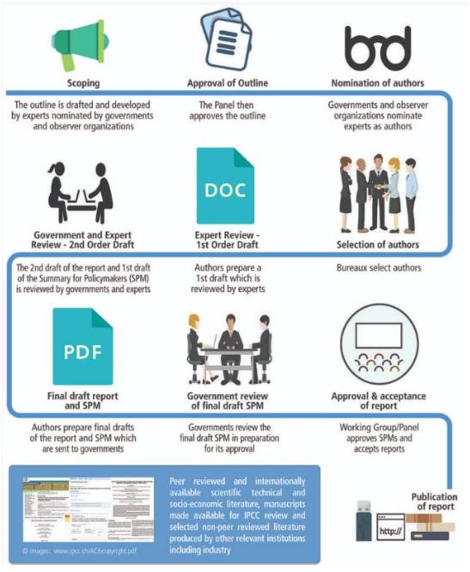

The preparation of an IPCC report begins with a scoping meeting at which experts nominated by governments and observer organizations draft a work plan. This plan must be approved by the Panel.
The observer governments and organizations then nominate experts to author the report. The authors prepare a first draft of the report. This first draft is reviewed by external experts and results in a second draft. The second draft is submitted to governments and other experts for review.
This gives member countries the opportunity to comment throughout the conceptualization phase of the report.
The IPCC analyses these observations and comments and adapts the report if necessary. The final report and the Summary for Policy Makers (SPM) are sent to governments. Governments review the final report and SPM for approval. It is only after this lengthy process that IPCC reports and their SPMs are approved.
- The reports we use most frequently in this query are the 2007 (AR4), 2014 (AR5) and 2021 (AR6.I) Assessment Reports and the October 2018 Special Report (SR 1.5°C).
Like 194 other countries, Belgium is a member of the IPCC. This means that since the preparation of the first report in 1990, it has been involved in the preparation of each report and in their approval in plenary session. Since 1990, it has therefore been systematically kept abreast of developments in scientific, technical and socio-economic knowledge relating to climate change.
- In conclusion, the IPCC reports represent the best available science at the global level. The specific process of preparation and approval of the IPCC reports makes them an unquestionable and undisputed scientific reference within the international community. In this case, the science is not in dispute. All States Parties to the UNFCCC share the same scientific data and recognize its authority in developing their policies to combat global warming.
The above process ensures a comprehensive, objective and transparent assessment of the current state of scientific knowledge on global warming. The resulting reports are highly authoritative.
- It should also be noted that, with regard to the process of preparing and approving the reports, they are systematically on the "conservative" side, given that certain countries producing harmful energy sources carry a great deal of weight in the above-mentioned process.
II.1.2 Global warming and CO ₂
- The respondents do not go back to basic facts such as the explanation of the greenhouse effect and the impact of anthropogenic greenhouse gas (GHG) emissions. These facts have not been disputed by the Respondents or by the judgment under appeal.
- To summarize, the warming of the earth that causes global warming is mainly caused by human use of fossil fuels. The scientific community agrees that anthropogenic GHG emissions are the main cause of global warming.
A. The anthropogenic origin of global warming
20. This graph summarizes the evolution of CO concentrations in the ₂atmosphere over 800,000 years. It shows that, over 800,000 years, these concentrations have fluctuated between 180 ppm and 300 ppm. So over the last 800,000 years, the concentration of CO₂ was 180 ppm during the coldest glacial periods and 300 ppm during the warmest interglacial periods. Then, suddenly, they increased dramatically, exceeding 400 ppm in a few hundred years, to reach 405 ppm in 2017.
This spectacular and rapid increase in CO concentrations₂ in the atmosphere coincides with the industrial revolution - which began around 1750 - and its subsequent evolution, and particularly with one aspect of this revolution: the demand for energy, specifically the use of fossil fuels (coal, oil, gas, lignite...).

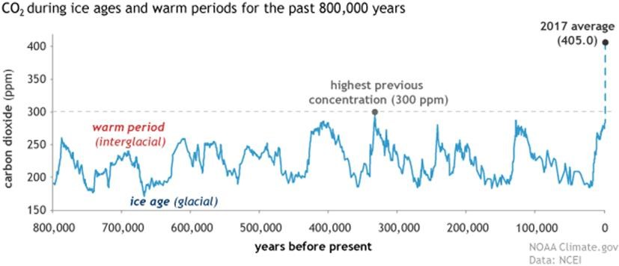

Figure 1. CO concentrations ₂ in the atmosphere over the past 800,000 years
- Today, the concentration of CO₂ in the atmosphere continues to increase at a high rate. If in 2017, we counted 405 ppm, we are at the beginning of November 2021 at 413.77 ppm . The current concentration of CO₂ is therefore already 113 ppm higher than the concentration during the warmest interglacial periods. For 800,000 years, a difference of 120 ppm has made the difference between the coldest ice ages (180 ppm) and the warmest interglacial periods (300 ppm). In the light of this data alone, it is immediately clear what extraordinary global warming and climate changes await us in the future as a result of the concentration already reached of 113 ppm. There is a direct link between increasing CO concentrations ₂and increasing global temperature.
- The first part of the AR6 provides a very illustrative graph also for the last 2000 years:
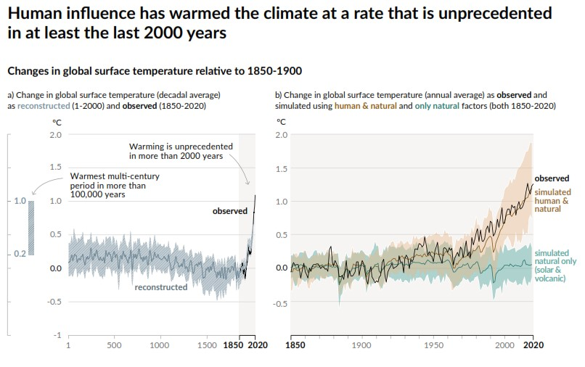

Figure 2. Global warming is due to human activity and has been increasing drastically since 1850, especially 1970
23. It will be argued in the following paragraphs that the best available science agrees that it is imperative to keep CO concentration ₂below 430 ppm CO ₂eq. to avoid dangerous global warming. The "window of opportunity", in other words "the space in which it is still possible to act", is extremely narrow.
The decade 2020-2030 will be decisive. We will come back to this.
B. Why is CO₂ particularly dangerous?
a Because of its quantitative importance
24. Of the major GHGs (carbon dioxide or CO ₂, methane or CH ₄, nitrous oxide or N ₂O and ozone or O ₃₎ it is clear that CO emissions ₂ are quantitatively the most important:
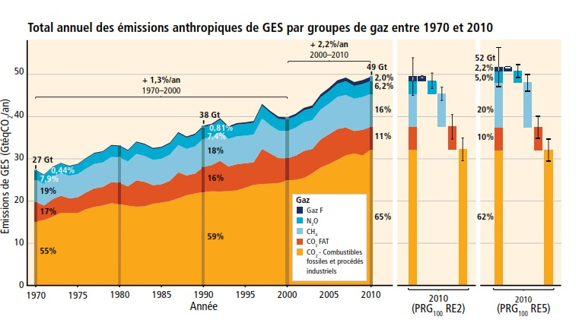

Figure 3. Total annual anthropogenic GHG emissions by gas group from 1970 to 2010
25. In particular, anthropogenic CO emissions₂ have increased steadily between 1750 and 2011, with an exponential acceleration from the 1970s.
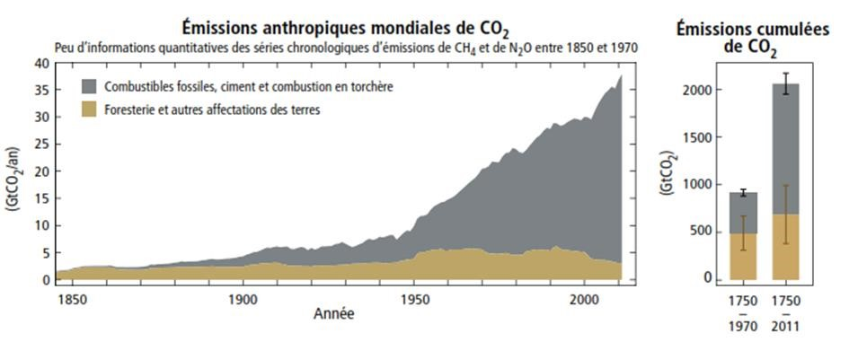

Figure 4. 1750-2011: Cumulative CO ₂
b Because of its longevity
- Furthermore, CO₂ is considered the most dangerous GHG because of its longevity. Once in the atmosphere, CO molecules ₂disappear only after several hundred years and in some cases even after millennia, retaining their warming properties in the meantime.
The ₂current CO concentration in the atmosphere therefore contains an accumulation of ₂anthropogenic CO emissions from 1750 to the present day. Anthropogenic CO₂ emissions have increased the concentration level of this GHG in the atmosphere by 40% since 1750 and have thus drastically changed the physico-chemical composition of the atmosphere.
- Since CO₂ is the most important part of the emissions, in quantitative as well as qualitative terms, the impact of other GHGs on global warming is expressed in equivalents of the warming value of CO₂ . Thus, the warming values of non-CO GHGs₂, such as methane, are commonly expressed in "CO-equivalents₂"₂. For a good understanding of the following, more technical part, it is good to know this.
It is important to distinguish between scientific statements and standards expressed in CO concentrations₂and those expressed in CO eq. concentrations ₂because the values in ppm (parts per million) are not the same, which can lead to confusion when reading IPCC reports. In the same vein, we must be careful about the specific meaning of the unit "ppm CO eq₂". The unit 'ppm' means 'parts per million'. For example, 300 ppm of CO ₂means that out of every million molecules in the atmosphere, 300 are CO ₂. When the unit "ppm CO ₂eq" is used, it is to describe the concentration of GHGs all together, where the concentration of non-CO GHGs ₂is reduced to a concentration of CO ₂based on their warming effect.
As a reminder, we are currently at a concentration of 413.77 ppm of CO₂in the atmosphere.
c Because of the linear relationship between increasing CO concentration ₂ and global warming
28. The relationship between the increase in the concentration of CO₂ in the atmosphere and the increase in temperature on earth is linear. This relationship is shown in the diagram below. The CO concentrations ₂(ppm CO₂ ) are shown in pink, with margins that take into account different modelling. The ovals indicate ranges of GHG concentrations for all scenarios (ppm CO eq.₂). It is clear that the increase in CO emissions ₂ (horizontal axis of the diagram) goes hand in hand with an increase in global average temperature (vertical axis of the diagram).
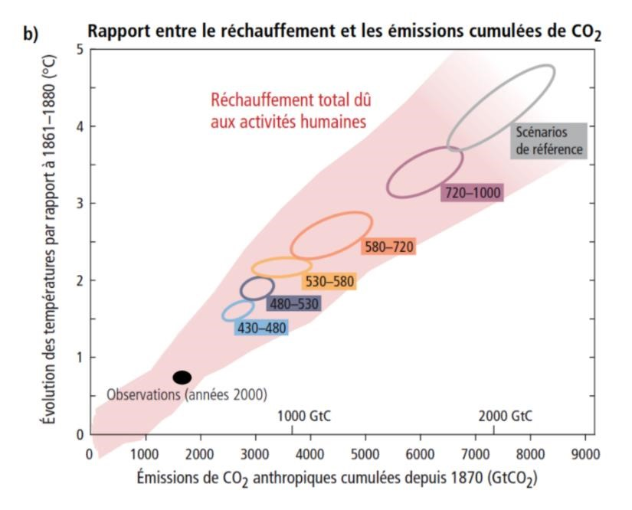

Figure 5: Relationship between global warming and cumulative CO₂and GHG emissions

29. AR6, part one, provides a very illustrative diagram in this regard as well.
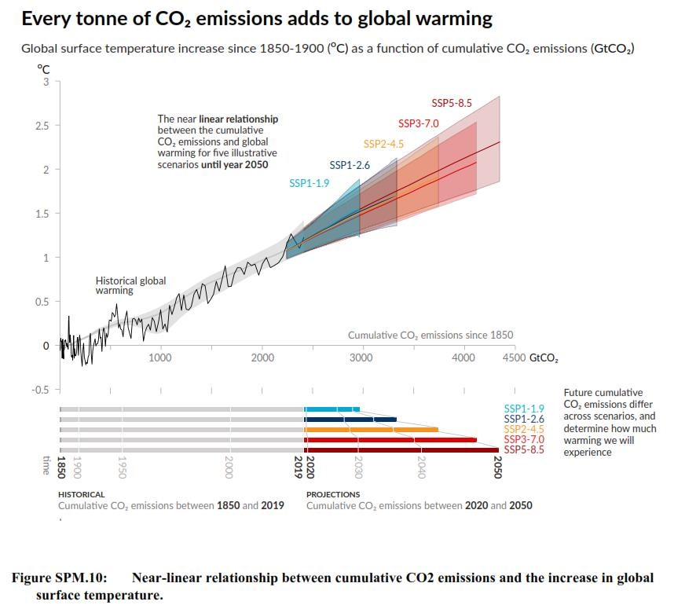

Figure 6. Relationship between global warming and cumulative CO₂
This linear relationship between cumulative CO emissions₂ and global warming forms the basis of the carbon budget concept in climate science. The carbon budget represents the total amount of CO₂that can be present in the atmosphere and that must not be exceeded if we want to stay below a certain global temperature threshold. This allows reasoning along the lines of: "We want to limit global warming to 3°C so we must limit CO emissions ₂to that much".
- The residual carbon budget is the amount of CO that ₂can still be emitted.

- These notions can be illustrated with the image of the bathtub:
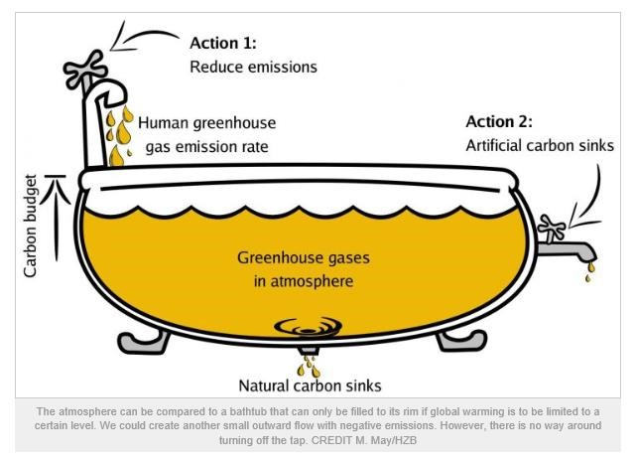

Figure 7 - Illustrative diagram of the 'bathtub
- If the edge of the bath is the maximum desired temperature, the carbon budget is the entire bath. The residual carbon budget is the margin/space available between the volume already in the bath (yellow) and the edge of the bath.
The importance of these two concepts, carbon budget and residual carbon budget, deserves to be emphasized. They are one of the key elements of global, regional and local climate governance.
- We will see that the IPCC has been working to determine the carbon budget and the residual carbon budget (in ppm) for what should be considered dangerous warming. The threshold for dangerous warming was initially set at 2°C, but was later abandoned in favour of 1.5°C.
C. Progressive and latent damage :
- A specific feature of climate cause data is the gradual and latent nature of the effects caused by GHG emissions.
- Progressive because the damage from global warming does not occur fully at any one time, but increases progressively as a result of the cumulative effects of concentrations.
- Latent because global warming, which causes climate change and damage, takes place with a time lag of about 40 years compared to the emissions that cause it.
The current global warming of more than 1°C is therefore mainly the consequence of the GHG emissions produced between 1750 and 1980. If global GHG emissions stop abruptly today, the global temperature will continue to rise exponentially for decades before stabilizing, especially in view of the meteoric rise in CO emissions ₂in the period from 1980 to now.
II.1.3 The key concept: dangerous global warming
- The ultimate objective of the UNFCCC is to "stabilize (...) concentrations of GHGs in the atmosphere at a level that would prevent dangerous anthropogenic interference with the climate system".
The 197 Parties to the UNFCCC - 196 countries including Belgium and the European Union - have therefore committed themselves to taking dangerous global warming as a reference point. The crucial question is at what point does the increase in the average global temperature imply dangerous warming.
Since 1990, various scientific studies have identified the threshold of 2°C compared to pre-industrial levels as the ultimate threshold that must not be exceeded.
An unquestionable consensus has emerged within the international community around the threshold of 2°C, then progressively 1.5°C, in light of the evolution of scientific knowledge.
To summarize:
  - The dangerous threshold of 2°C was first proposed in 2007 at the Bali Conference of the Parties (COP).
  - In the Copenhagen Accord (COP-15, 2009), states recognized the need to limit the temperature increase to 2°C and considered the possibility of strengthening the long-term objective towards a threshold of 1.5°C;
  - The objective of limiting the temperature increase to 2°C, and the need to consider strengthening the threshold with reference to 1.5°C, was reiterated at the Cancún Conference (COP-16, 2010) ³⁰;
  - At the Doha Conference (COP-18, 2012), a "Structured Dialogue among experts" was launched to adjust the 2°C threshold downwards. It concluded that the 2°C target should no longer be considered conservative, that the 2°C threshold had become inadequate to avoid dangerous global warming, and that limiting warming below 1.5°C would be safer;
  - The Paris Agreement (COP-21, 2015) set a goal of holding the increase in global average temperature "well below 2°C above pre-industrial levels" and continuing efforts to limit the temperature increase to 1.5°C ;
- None of the respondents has disputed that, as Belgium is a party to the UNFCCC and therefore to the COP, it has adopted by consensus the various decisions that this body has taken over the years, from meeting to meeting, from the 2007 COP to the 2015 COP, and that, in so doing, the country and therefore all the respondents were necessarily fully informed of these decisions.
³⁰ Decision 1/CP.16, preamble and p. 3, point 4, Exhibit H.9 :
"Recalling its decisions 1/CP.13 (Bali Action Plan) and 1/CP.15, [...]
Noting UN Human Rights Council resolution 10/4 on human rights and climate change, [...]
- The 2018 IPCC Special Report summarizes the differences between the consequences of 1.5°C and 2°C warming in a striking figure, which we reproduce below. A crucial finding of the IPCC study is that with warming above 1.5°C, all the dangers generated by induced climate change increase substantially. The following figure summarizes this: all relevant risks in relation to climate change become 'High' to 'Very high' at a warming between 1.5°C and 2°C.

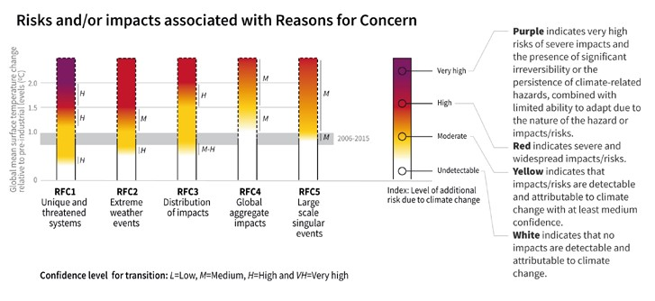

Figure 8. Warming of 1.5°C to 2°C and more: low to very high risk of consequences
Note that the risk of reaching these tipping points ('Large scale singular events') with irreversible changes is already close and becomes substantially higher above 1.5°C.

However, it should be remembered that there is no linear relationship between warming and the consequences of warming; such a linear relationship exists only between GHG concentrations and warming. The tipping point phenomenon is a perfect example.

II.1.4 The carbon budget: the GHG emission reductions required to avoid global warming
hazardous climate
40. Belgium therefore adhered by consensus to the COP decisions, setting the threshold for dangerous warming at 2°C first, then towards 1.5°C.
The question is to know what carbon budget this corresponds to. It is therefore a question of determining how much we should limit the concentration of GHGs in the atmosphere in order to limit the rise in temperature to 2°C or even 1.5°C.
A. 2°C - 450 ppm CO₂ -eq. - at least 25 to 40% reduction in GHG emissions by 2020 - at least 85 to 90% by 2050 a The carbon budget: 450 ppm CO₂-eq. to limit to 2°C
- Within the global climate governance established by the UNFCCC, the idea of quantifying the limit of dangerous warming, the threshold of average global temperature increase not to be exceeded, appeared for the first time in 2007, during the COP-13 in Bali. Chronologically, the approach comes a decade after the 1997 Kyoto Protocol (which entered into force in 2005), which, although it provides for GHG reduction commitments for State Parties, did not give concrete form to the notion of "dangerous global warming".
- The preamble to the Bali Action Plan explicitly recognizes the following:
"The Conference of the Parties,
Determined to strengthen the implementation of the Convention as a matter of urgency in order to achieve its ultimate objective in full compliance with the principles and commitments of the Convention, (...)
Recognizing that deep cuts in global emissions will be required to achieve the ultimate objective of the Convention and stressing the urgency of addressing climate change, as stated in the Fourth Assessment Report of the Intergovernmental Panel on Climate Change (...)".
In the word "urgent" there is a footnote. This footnote refers to the following table:
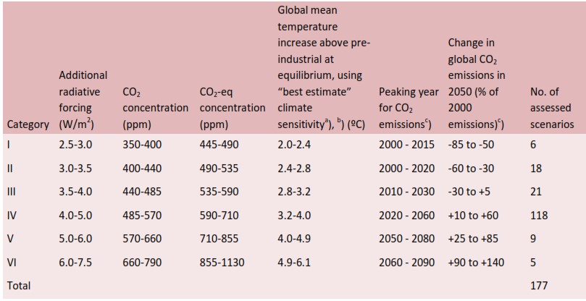

Figure 9: IPCC 2007 Assessment Report: The 2°C Limit
In this table, the IPCC has provided extremely clear information on the concentration limits (in ppm CO ₂-eq) that must not be exceeded to stay below a certain global temperature.
Thus, the information under "Category I" shows that in order to limit warming to between 2°C and 2.4°C, the concentration of GHGs in the atmosphere must be stabilized at a level between 445 and 490 ppm CO ₂-eq.
Note that this hypothesis assumes that the ceiling for global CO emissions ₂("Peaking year for CO₂ emissions") is reached between 2000 and 2015 and that these emissions then decrease, which has not been the case. And in 2007, at COP-13, we already knew that from 2000 to 2007 these global emissions had continued to increase year after year and that the limit concentrations put forward were therefore too optimistic. We will come back to this later. Moreover, the ceiling on global CO emissions ₂has still not been reached.
The IPCC, on the basis of the table reproduced above, including the premise of a CO2 emissions cap between 2000 and 2015, concludes that the temperature rise can only reasonably be limited to 2°C if the concentration of GHGs in the atmosphere stabilizes at a maximum of about 450 ppm CO ₂-eq :
"Limiting the temperature increase to 2°C above pre-industrial levels can only be achieved at the lower limit of the concentration range indicated in the Category I scenario (i.e., about 450 ppm CO equivalent ₂based on "best estimate" assumptions).
In summary, as early as 2007, the Respondents knew that in order not to exceed the 2°C threshold, which corresponds to dangerous global warming, GHG concentrations had to be limited to 450 ppm CO ₂-eq.
b Measures to be taken to limit GHG concentrations to 450 ppm CO ₂-eq: emission reductions of at least -25 to -40% by 2020
- The question remained: what actions should be taken to limit GHG concentrations to 450 ppm CO ₂-eq? The answer to this question leads us to visit some principles enshrined in the UNFCCC.
- Article 3 of the UNFCCC sets out the guiding principles for action by each Party to achieve the Convention's objective of avoiding dangerous warming, including
the principle of common but differentiated responsibilities, taking into account in particular the respective capacities of the Parties, and which places the developed countries, including Belgium, at the "forefront of the fight against climate change and its harmful effects";
the precautionary principle, which states that lack of full scientific certainty shall not be used as a reason for postponing preventive measures.
The UNFCCC also sets out the commitments of the Parties, distinguishing between the obligations of the States listed in Annexes I and II and those of the States not listed.
Annex I to the Convention groups together the "developed countries", i.e. the industrialised countries that were members of the OECD in 1992, as well as countries whose economies were in transition towards a market economy, in particular Russia and several Eastern European countries. 43 countries are included in this annex, including Belgium, out of the 196 States Parties to the UNFCCC.
Annex II includes some of the Annex I countries, i.e. only the members of the OECD, i.e. 24 of the 43 so-called "developed countries". It is therefore the hard core of Annex I and Belgium is part of it.
For example, Bulgaria, one of the poorest countries in Europe, is still included in Annex I as a developed country. However, it is not included in Annex II. Annex II countries therefore have a very special status.
The principle of common but differentiated responsibilities is based on this classification. Indeed, the obligations under the UNFCCC - and then under subsequent treaties - are more binding for these developed countries than for non-developed countries and not listed in the annexes.
As an Annex I country, coupled with Annex II status, Belgium is one of the richest countries in the global community and has a leadership responsibility in climate governance.
- Even before the adoption of the Bali Plan in December 2007, Annex I countries to the UNFCCC recognized the need to reduce their emissions by 25-40% by 2020 compared to 1990 levels. This is reflected in the August 2007 Report of the "Ad Hoc Working Group on Further Commitments for Annex I Countries under the Kyoto Protocol", which refers to the IPCC Fourth Assessment Report:
" The AWG-KP noted the usefulness of the ranges referred to in the Fourth Assessment Report [AR4, IPCC]. Recognizing the findings of the contribution of Working Group II on impacts, vulnerability and adaptation, (...) Annex I Parties should collectively reduce their emissions to between 25 and 40 per cent below 1990 levels by 2020 through the means that may be available to them to achieve these targets. These ranges are taken from Box 13.7 of the Working Group III report. They would also be much higher if only Annex I parties were to reduce their emissions. The AWG-KP noted that the ranges of the IPCC do not take into account possible lifestyle changes that could increase the ranges. The AWG-KP further recognizes that, if Annex I Parties were to achieve these reduction targets, they would make a significant contribution to the global efforts required to achieve the ultimate objective of the Convention, as set out in its Article 2.
Thus, this Working Group of Annex I parties, of which Belgium is a member, recognised - even before COP-13 (Bali, 2007) - that a reduction of 25 to 40% by 2020 is necessary and that this range could even be revised upwards.
- Box 13.7 of the IPCC AR4, to which the above quote from the Ad Hoc Working Group of Annex I countries to the Kyoto Protocol refers, is as follows. It clearly indicates the percentage of GHG emission reductions that Annex I countries must achieve in 2020 (25-40%) and in 2050 (80-95%) to meet the 450 ppm CO ₂-eq limit. This would make it possible to avoid dangerous warming exceeding 2°C. Let us recall that this 2007 IPCC report considered that global emissions would stabilize between 2000 and 2015, and then decrease, an assumption that ran counter to the realities observed at the time it was written and approved. Let us note the impact of this over-optimistic assumption on the reductions required to meet the 450 ppm CO ₂-eq limit. As the accumulation of GHGs in the atmosphere has simply continued to increase instead of stabilizing and then decreasing, the required reduction percentages for 2020 and 2050 have necessarily slipped towards the top of the range: towards 40% and 95%. Indeed, there is a communicating vase effect: the higher the GHG emissions in the atmosphere, the higher the percentage of emission reductions that will allow us not to exceed the 450 ppm limit.
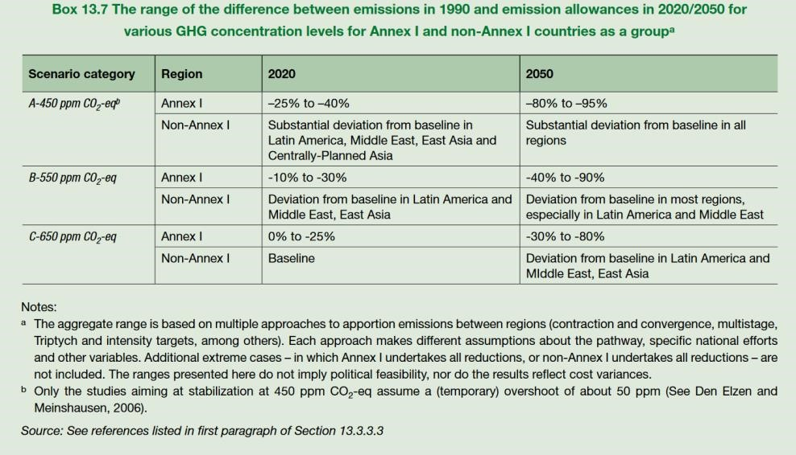

Figure 10 - IPCC - 2007 Assessment Report (AR4): the necessary percentages of global GHG emission reductions to stay below the 2°C threshold.

In summary, as early as 2007, respondents knew that to avoid the dangerous 2°C warming, Annex I parties had to reduce their GHG emissions by at least 25-40% by 2020, and by at least 80-95% by 2050 (compared to 1990 levels). This is based on the assumption that global GHG emissions would stabilize between 2000 and 2015, and then decline.
- The need for Annex I Parties to reduce their emissions by at least 25-40% by 2020 has been repeated from COP to COP:
  - COP-15 (2009) Copenhagen;
  - COP-16 (2010) Cancun; - COP-17 (2011) Durban;
  - COP-18 (2012) Doha;
  - COP-19 (2013) Warsaw; - COP-20 (2014) Lima; - COP-21 (2015) Paris.
- It appears from the above that from COP-13 in Bali in 2007 to COP-21 in Paris in 2015, it has been agreed and re-agreed each year that, to avoid dangerous warming understood as 2°C, Annex I countries should reduce their GHG emissions by at least 25-40% by 2020.
The Party countries themselves, including Belgium, have therefore not only determined, on the basis of the best available and universally accepted science, what the threshold of dangerous warming is, but they have also determined what measures should be taken to avoid exceeding this threshold. This factual finding is very important. We will come back to it later.
B. 1.5°C - 430 ppm CO ₂-eq. - necessarily more than 25 to 40% reduction in GHG emissions by 2020
- The international consensus has gradually formed around abandoning the 2°C threshold and moving towards the 1.5°C target.
- In its AR4, the IPCC indicates that limiting the temperature increase to 1.5°C implies a global carbon budget of 430 ppm CO ₂-eq .
- What actions were needed to limit GHG concentrations to 430 ppm CO ₂-eq?
It is clear that if Annex I Parties were to reduce their emissions by at least 25-40% by 2020 to avoid exceeding 450 ppm CO ₂-eq (and by 80-95% in 2050), they would necessarily have to reduce even more by 2020 to avoid exceeding 430 ppm CO ₂-eq.
Thus, just because the 430 ppm CO ₂-eq target was not explicitly translated into new emission reduction percentages in successive COPs does not mean that reductions were not needed. States Parties were well aware of what they had to do to avoid dangerous warming.
The explicit recognition by the respondents of the need to reduce the
GHG emissions by at least 25% to 40% by 2020
- It follows from the above that it is impossible that the Respondents were not aware of the percentages of emission reductions since 2007:
  - As a member of the IPCC, Belgium followed the elaboration and conclusion of the AR4 of 2007, which played a pivotal role in the knowledge and dissemination of the reduction percentages required to avoid dangerous warming understood as a warming of 2°C;

  - As a Party to the UNFCCC and more specifically as an Annex I Party to the UNFCCC, Belgium was present at the COP and MOP decisions in Bali (2007), Poznan (2008), Copenhagen (2009), Cancun (2010), Durban (2011), Doha (2012), Warsaw (2013), Lima (2014) and Paris (2015) where the need for these reductions for Annex I countries was made explicit and the respondents were involved in these diplomatic meetings.
- Not only were the respondents aware of the mitigation measures to be taken, but they expressly acknowledged the scientific need for them.
- This is evidenced by official documents of the time. These documents show that the Respondents were aware of their heightened responsibility as an Annex I developed country.
For example, in view of the COP-15 in Copenhagen, the Belgian Parliament requested, in a resolution of 3 December 2009, that the federal government advocate, on an international scale, a reduction of greenhouse gases by 25-40% by 2020 and 80-95% by 2050.
As far as the Flemish Region is concerned, we can report the following documents.
An opinion of the Minaraad (Flemish Council for the Environment and Nature) to the Flemish Parliament of 4 December 2009 states the following with regard to 2020:
"According to the Fourth Assessment Report, the group of developed countries needs to reduce its emissions by 25-40% below 1990 levels by 2020 in order to limit the temperature increase to 2-2.4°C. The Minaraad emphasizes that the emission reductions needed for developed countries will have to be at the higher end of this range (25-40%)" (emphasis added)
With regard to 2050, the Minaraad, again in 2009, clarifies the following:
"That emissions should be reduced by 80-95% by 2050 compared to 1990 levels. Minaraad... points out that there are more recent studies that indicate that global reductions should be greater than those projected by the IPCC in its latest report (+50%)" (emphasis added).
On the basis of these findings, the Flemish Parliament adopted a resolution on 9 December 2009 in which the necessary reduction percentages for 2020 and 2050 were included:
"The precautionary principle implies that for the group of developed countries reduction targets of 25-40% are needed in 2020 compared to 1990 and at least 80-95% in 2050 compared to 1990" (emphasis added).
In addition, the Flemish Environment Report ("Milieurapport") concluded in 2009 that the current traditional policy instruments are insufficient to initiate and accelerate the transition to a sustainable low-carbon economy.
Finally, it should be noted that the Flemish Parliament already stated in 2009 that "the total greenhouse gas reduction percentages put forward by Annex I countries are insufficient to come close to the 2°C objective" (emphasis added).
In Wallonia, the regional parliament adopted on 20 February 2014 a Climate Decree providing for a reduction target of 30% in 2020 and 80-95% in 2050, following a Climact study finalised on 30 December 2011 .
The inadequacy and insufficiency of the norms of positive international law and
for 2020
- We have just traced the path of the authorities' knowledge of the danger of global warming, but above all of the measures to be taken by the States Parties to the UNFCCC to prevent this danger from occurring. It is clear from the foregoing that Belgium, and therefore the respondents, knew as early as 2007 precisely what they had to do to help avoid dangerous global warming. They knew that in order to avoid a warming of 2°C, the Annex I Parties, of which Belgium was a part, had to reduce their emissions by at least 25% to 40% by 2020, and 80 to 95% by 2050. They knew that in view of their historical responsibility and leadership in climate policy, their share of emission reductions was at the high end of the range and closer to 40% than to 25%. They knew that the assumption of a global emissions ceiling between 2000 and 2015, on which the percentages of emissions reductions were based, was contradicted by the facts, also pushing the effort towards 40%. Finally, they were necessarily aware that in order to move towards the 1.5°C threshold, the target of at least 25% to 40% was itself out of date, so that even more reductions were needed.
- Any normally diligent authority under the same conditions - having therefore followed all the IPCC work and contributed to all the COP decisions - should have deduced that, in order to move towards the 1.5°C threshold to avoid dangerous warming, it had to move towards a 40% emissions reduction by 2020. Countries such as Germany, Denmark, the UK and Sweden, for example, strengthened their climate policies in the years after COP-15 (2009) in Copenhagen, adopting a 40% reduction in GHG emissions by 2020 as a cornerstone of that policy.
- The understanding of the facts of the case may be somewhat confused by the adoption of binding targets enshrined in Belgian positive law, namely on the one hand the targets resulting from the Kyoto Protocol, and on the other hand the targets imposed by the European Union.
It should be noted from the outset that these binding targets are largely insufficient and simply do not prevent dangerous warming. They have the merit of existing, but they are not sufficient to define the standard of behaviour that is required of the authorities.
The authors insist that these binding objectives cannot constitute the reference for defining the standard of conduct imposed by Articles 2 and 8 ECHR and by Article 1382 of the Civil Code, since they do not make it possible to avoid dangerous warming. The aim is to determine the conduct of an authority faced with the imminence of a serious danger threatening its population. It will be recalled, if necessary, that a normally diligent authority takes adequate and necessary measures.
A normally diligent authority does not refrain from taking measures by taking refuge behind obligations cast in the form of norms of positive law in the full knowledge that these are not adequate to protect its population from the danger.
- In this case, two norms of positive law must be cited. In the following lines, the Court will endeavour to clarify whether they are inadequate and insufficient to prevent dangerous global warming, and therefore irrelevant for the determination of the standard of conduct to be imposed on the Respondents.
II.3.1 The objectives set by the European Union
- On the basis of political decisions dating back to 2007, on 23 April 2009 the European Union introduced a set of laws commonly referred to as the "Climate and Energy Package", with the objective of reducing GHG emissions by 20% by 2020 compared to 1990, or 14% compared to 2005, it being understood that the contribution of each member country will be determined taking into account its characteristics.
For Belgium, this has resulted in the following target: 21% reduction of its GHG emissions compared to 2005, for 2020.
- Given the evidence of scientific knowledge and the international consensus that has formed around the range of at least 25% to 40% reduction, it is clear that the EU target of 20% for 2020 was far from sufficient to avoid dangerous warming.
- A 2007 Communication from the European Commission, which forms the basis of European legislation for 2020, has a telling title: "Limiting Global Warming to 2 degrees Celsius. The road ahead to 2020 and beyond". It invokes "irrefutable scientific facts".
It is therefore interesting to read in the same Communication the following:
"This Communication proposes that the EU should set a target in the international negotiations to reduce greenhouse gas (GHG) emissions from developed countries by 30% (compared to 1990 levels) by 2020. This effort is necessary to limit the increase in global temperatures to 2 degrees Celsius" (emphasis added).
Indeed, while it is estimated that the EU should reduce its GHG emissions to -30% below 1990 levels in order to limit the rise in global temperatures to 2°C, the objective adopted was, as we have explained above, to reduce emissions by 20% by 2020. An insufficient target according to the European Commission itself.
- Furthermore, in the wake of the Bali COP, the European Parliament also clearly stated in a resolution of 31 January 2008 that :
"Parliament welcomes the decision by the parties at the Bali Conference to launch a formal negotiation process to reach an international climate agreement for the period after 2012. (...) However, MEPs welcome the fact that the parties to the Kyoto Protocol recognise the need for industrialised countries to reduce emissions by 25-40% by 2020 (compared to 1990 levels)" (emphasis added).
The inadequacy of the 20% target has in fact been explicitly recognised by the European institutions:
  - A 28 January 2010 letter from the European Union to the UNFCCC Executive Secretary states that, in light of the IPCC findings, developed countries should reduce their GHG emissions by 25-40% by 2020 compared to 1990 levels to meet the 2°C warming limit.

  - Like the European Commission in 2010, the European Council also concluded as early as 2009 that the EU's 20% target for 2020 was far from sufficient on scientific grounds and would have to be significantly revised to avoid 2°C warming. This is reflected in the preamble to Directive 2009/29/EC, which amends the ETS Directive 2003/87/EC. This preamble considers, among other things, the following:
"(6) In order to increase the degree of certainty and predictability of the Community scheme, it is appropriate to make provisions to enhance the contribution of the Community scheme to the achievement of an overall reduction of more than 20%, in particular in view of the 30% target by 2020 set by the European Council, this being the level considered scientifically necessary to avoid dangerous climate change.

  - With these positions, the European Commission and the European Council are aligning themselves with an opinion of the European Economic and Social Committee (EESC) of 3 February 2009 addressed to them. The EESC had also concluded that the EU's 20% target for 2020 was not adequate in view of what the 196 UNFCCC Parties had decided in the 2007 Bali Action Plan:
"In this context, it should be noted that the EU's target of a 20% reduction in greenhouse gas emissions by 2020 compared to 1990 levels (...) is aimed at a lower level than the 25-40% reduction for industrialised countries that the EU called for at the Bali climate conference in December 2007 (...) The EESC concludes that, in view of the growing evidence of climate change, the targets should be adjusted to achieve deeper cuts in greenhouse gas emissions.
However, the 20% target for 2020 has never been adjusted.
- In conclusion, it is clear that European climate policies for 2020 are insufficient to avoid dangerous warming, which was determined at the time to be 2°C, not 1.5°C.
- Another observation, in addition to the first, is that the European institutions know that their policies are insufficient and do not hesitate to communicate this in official documents.
- In view of the above, it must be concluded that the reduction target imposed on Belgium by the European Union for 2020 is not a relevant reference for defining the standard of behaviour which is binding on Belgium under Articles 2 and 8 of the ECHR and Article 1382 of the Civil Code.
While it is not disputed that this is a binding objective to which Belgium has committed itself, this is not such as to impede the analysis of the conduct of the Belgian authorities in the light of their knowledge of the danger and the measures to be taken to avoid it. Indeed, the Belgian authorities' conduct in taking refuge behind the European objectives, which they knew to be largely inadequate in the light of their knowledge of the measures to be taken to avoid dangerous warming, is incompatible with the standard of conduct imposed both by Articles 2 and 8 of the ECHR and by Article 1382 of the Civil Code.
II.3.2 The 1997 Kyoto Protocol, as amended by the 2012 Doha Amendment
- Article 3 of the Kyoto Protocol states that:
"The Parties included in Annex I shall, individually or jointly, ensure that their aggregate anthropogenic emissions (...) do not exceed their assigned amounts, calculated pursuant to their quantified emission limitation and reduction commitments inscribed in Annex B."
The Doha Amendment amended Annex B of the Kyoto Protocol. In its amended version, it sets a GHG emission reduction target for Belgium of 20% below 1990 levels by 2020.
Again, in view of the scientific knowledge and the international consensus that formed as early as 2007 around the 25-40% reduction range, it is clear that the 20% target for 2020 was largely insufficient to avoid dangerous warming.
- Moreover, it should be recalled that the Kyoto Protocol (1997) was concluded at a time when the 2°C threshold was not yet formally the subject of an international consensus, although reference had already been made, notably by the European Commission, to the 2°C threshold to avoid dangerous warming as early as 1996. The 1997 reduction targets were set without any reference to the 2°C threshold not to be exceeded. The wording of Article 3 of the Kyoto Protocol must therefore be read in the light of the context in which it was drafted. The political consensus on the effort needed to avoid dangerous global warming - a consensus based on the IPCC reports - has become much clearer since then.
- The amendment to the Kyoto Protocol was adopted at the end of the 2012 COP in Doha. It should be remembered that the reduction target of at least 25-40% for Annex I countries had been repeated successively from COP to COP, year after year, since 2007. The Doha amendment was therefore clearly an outdated target even before it came into force. It is all the more interesting to note that the Doha amendment entered into force on 31 December 2020. The amendment imposed a 20% reduction target for the 2013-2020 commitment period. It therefore entered into force on the day it expired: a stillbirth.
- In view of the above, it must be concluded that the reduction target imposed on Belgium by the Doha Amendment is not a relevant reference for defining the standard of conduct imposed on the respondents by both Articles 2 and 8 of the ECHR and by Article 1382 of the Civil Code.

III. Statement of Basic Facts: Part II
On the importance of a minimally linear pathway for GHG reductions
70. In its judgment of 26 June 2015 in the Urgenda case, the Court of First Instance in The Hague addresses the link between the GHG emissions reduction trajectory towards a given target over 2050, on the one hand, and the volume of GHG emissions produced in pursuit of that target, on the other. In time, the judgment is before the Paris Agreement. The objective for 2050 is a reduction in GHG emissions of 80-95%, as put forward by the IPCC since 2007. The judgement uses the following diagram presented by Urgenda:
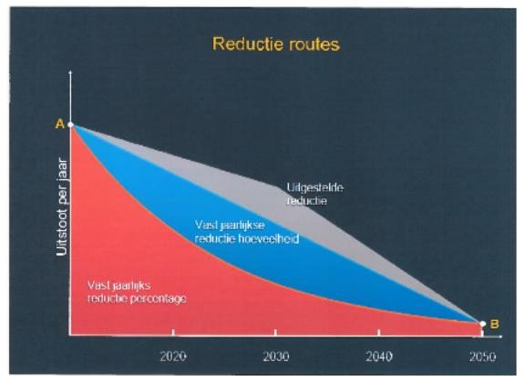

Diagram 11. Scheme used in the judgment of 26 June 2015 in the Urgenda case
The red area below the concave line connecting point A to point B indicates the total volume of GHG emissions assuming a concave GHG emissions reduction pathway is followed to achieve the 2050 target.
The red and blue areas below the straight line that connects point A to point B show the total volume of GHG emissions under the assumption that a linear GHG emissions reduction pathway is followed to reach the same target over 2050. The total volume of emissions is higher here than in the previous scenario because the volume of emissions in blue is added to the volume of emissions in red.
The sum of the red, blue and grey areas indicates the total volume of GHG emissions under the assumption that a deferred GHG emissions reduction pathway is followed until 2030, and then accelerated to reach the 2050 target. The total volume of emissions is significantly higher than in the two previous assumptions. Indeed, to the red and blue emission volumes, the grey emission volume is added.
The Tribunal's considerations in relation to this scheme are twofold. First, they refer to the impact of the reduction path followed on the total volume of emissions. Second, they point to the impact of the path followed on the chances of achieving the objective pursued.
"According to Urgenda, the first diagram (...) shows that a deferred reduction pathway results in higher emissions than choosing an equal distribution of reduction effort over the entire period to 2050 or a linear approach. It argues that the diagram also shows that deferring reductions (reducing less until 2030 and more from that year onwards) results in higher emissions overall and therefore increases the likelihood of exceeding the remaining 'budget'. Urgenda also argues that it is more cost-effective to act now. This is based on the IPCC's Fifth Report, which states that scenarios in which deep cuts are postponed to the period between 2030 and 2050 lead to a greater reliance on CO ₂However, according to the same report, these technologies are not yet sufficiently developed to be able to contribute substantially to the reduction.
71. We shall return to the importance of the GHG emission reduction trajectory adopted to achieve the objective. We will apply this to the current Belgian situation.
The main thing at this stage is to understand that the reduction trajectory followed towards a reduction target is not a neutral data. The choice of trajectory can guarantee the respect of a certain available emissions budget or, on the contrary, ensure that it is not respected. It can also, from a socio-economic point of view, give more chances to reach the target or, on the contrary, decrease these chances.
It should also be noted that the convex reduction pathway is the one that consumes the most GHG budget and leads to severe reduction efforts at the end of the journey.

- Statement of Basic Facts: Part III
As for the climate emergency and the need to rule as quickly as possible on this case
  - Since the 2015 Paris Agreement, the scientific and internationally recognized consensus enshrined in the Agreement explicitly states that to avoid dangerous warming, the target must be "well below 2°C" and move towards 1.5°C.
According to the AR6.I of August 2021 a global residual carbon budget at 500 GtCO₂ gives a one in two chance (50% chance of success) of meeting the dangerous warming limit. To have two chances out of three to respect this limit (67% chance of success), the global residual carbon budget has 400 GtCO₂ . However, to date, GHG emissions have still not reached their ceiling ('peaking'). On the contrary, they continue to increase year after year. CO emissions are ₂currently around 40GtCO₂ per year. At this rate, we have a decade or even a dozen years left to do what is necessary. It is therefore a global emergency. It is also urgent for this country. The global residual carbon budget is a common good for humanity and all life on the planet. No country has the right to monopolize it too much, developed countries and Annex II countries much less than others. Belgium is such a country. The global emergency brings with it an emergency at the level of the countries, particularly the developed countries. In order to meet our share of the budget, an urgent effort on the part of the respondents is required. We will detail this later.
  - Global warming that is not significantly below 2°C is a major danger for all of humanity, without exception. Everyone will be affected in some way by the effects of such warming. The first part of the AR6 is again unequivocal on this point.
  - In view of this exceptional situation and the urgency described, it is absolutely necessary for Your Court to rule on this case as soon as possible.

- Purpose of the call
  - The present appeal seeks to reverse in part the judgment under appeal insofar as it held:
        - That, for the year 2020, the results obtained by the respondents had to be measured exclusively against the binding GHG emission reduction target enshrined in the Doha Amendment (international level), the binding GHG emission reduction obligations in non-ETS sectors enshrined in Decision 406/2009/EC (European level) and the intra-Belgian GHG emission reduction obligations enshrined in the cooperation agreement of 12 February 2018 (national level) by refraining from measuring them against the standard of behaviour imposed by Articles 2 and 8 of the ECHR and Article 1382 of the Civil Code with regard to the authorities' knowledge of the danger threatening their populations and the measures to be taken to help prevent or limit it;
        - That the principle of separation of powers would preclude the Tribunal from imposing GHG emission reductions on the respondents;
        - That the UNFCCC has been amended by the Kyoto Protocol and the Paris Agreement;
        - That the judge must exercise marginal control over the compliance of the respondents with the standard of conduct imposed by Articles 2 and 8 of the ECHR and by Article 1382 of the Civil Code;
        - That adaptation, like mitigation, is an appropriate measure against global warming and that the scientific community agrees on the need to contain the concentration of GHGs at 450 ppm by 2100.

First complaint: the emission reduction targets imposed by the standard of conduct within the meaning of Articles 2 and 8 of the ECHR and Article 1382 of the Civil Code must be determined in the light of the authorities' knowledge of the danger threatening their populations and the measures to be taken to help prevent or limit it
V.1.1 Reminder and criticism of the judgment
  - The major difficulty in this case lies in the distinction between, on the one hand, scientific knowledge and the recognition by the international community of the measures to be taken to avoid the danger of dangerous global warming, and, on the other hand, the tangle of international and European law standards, known as positive law standards, which have been reflected in intra-Belgian national positive law (cooperation agreements), the quantified objectives of which do not coincide with the measures that are necessary in the light of this scientific knowledge.
  - The present action is based on the recognition of fault on the part of the Respondents, not on the basis of the violation of a norm of international or European climatic law, but on the basis of the standard of conduct imposed by both Articles 2 and 8 of the ECHR and Article 1382 of the Civil Code.
The conclusion is that the standard of behaviour of the authorities should be defined in terms of their knowledge of the danger of global warming, its severity, and what needs to be done to help prevent it, or at least limit it.
It is not a question of debating whether the respondents have fulfilled their obligations under international, European or Belgian positive climate law.
The Court's task is to determine whether, in the light of the authorities' knowledge of the danger and of the urgent measures to be taken to help prevent or limit it, they complied with their positive obligations under Articles 2 and 8 of the ECHR and acted as normally prudent and diligent authorities within the meaning of Article 1382 of the Civil Code.
  - This clarification is necessary since the judgment seems to have confused the two - yet distinct - sources of fault within the meaning of Article 1382 of the Civil Code. In fact, in order to establish fault, the Court of First Instance considered that, with regard to the period elapsing in 2020, :
      - At the international level, "the only binding target for Belgium for 2020 is the 20% reduction in GHG emissions" ⁶⁶included in the Doha amendment;
      - At European level, the only GHG emission reduction obligations to be met by 2020 are those set out in Decision 406/2009/EC, which concern non-ETS sectors⁶⁷;
      - at the domestic level, the only GHG emission reduction obligations to be met by 2020 are those set out in the cooperation agreement of 12 February 2018
68.
These standards of international, European and national climate law have been considered to the exclusion of the standard of conduct deriving from Articles 2 and 8 of the ECHR and Article 1382 of the Civil Code with regard to the authorities' knowledge of the danger and the urgent measures to be taken to help prevent or limit it.
79. The respondents wish to limit this appeal strictly.
Indeed, the judgment under review concluded that there was a fault based on a triple finding:
  - the poor results in terms of figures, assessed exclusively in relation to the obligations set out in international, European and national positive climate law;
  - the lack of good climate governance; and repeated warnings from the European Union.
The findings do not call into question the Tribunal's findings of poor performance, lack of good governance and repeated warnings from the European Union.
What they challenge is the assertion that only objectives enshrined in positive international, European and national domestic climate law standards are binding. Indeed, such an assertion amounts to confusing the fault by failure to comply with the norm of behaviour with the fault by failure to comply with the norm of positive law.

⁶⁶ Judgement undertaken, p. 67 Ibid⁶⁷, pp. 68-69.
⁶⁸ Ibid, p. 71.
However, the judgment under review itself recalled the principle established by the Court of Cassation in its judgment of 25 October 2004, according to which fault has its origin in two distinct sources:
"The fault of the administrative authority, which may, on the basis of articles 1382 and 1383 of the Civil Code, engage its liability, consists of conduct which either amounts to an error of conduct to be assessed according to the criterion of the normally careful and prudent administrative authority placed in the same conditions, or (...) violates a norm of international law or of an international treaty having effects in the internal legal order, requiring that authority to refrain from or to act in a specific manner".
It follows from the foregoing that the standard of conduct is not the same as the obligations of positive law. It is analysed in the light of a standard of conduct, defined both in the light of existing norms of positive law and in the light of all the particular circumstances of the case.
By confining itself to taking as a reference only the emission reduction targets laid down by the rules of positive international, European and Belgian law, and consequently refraining from analysing the authorities' conduct in the light of their knowledge of the danger and of what needed to be done to help prevent or limit it, the Court of First Instance erred in law.
This is all the more so since the Tribunal itself has acknowledged the following: "Finally, science evolves, as demonstrated in particular by the successive IPCC reports. It is therefore in the light of the scientific knowledge available at a given time that the degree of knowledge of the risks is assessed, and hence the conduct of the public authorities in relation to those risks"⁷⁰, a consideration which is typically endorsed by the standard of conduct.
- Although the respondents were successful in finding fault in the end, the correction of this error in law is fundamental, since it is also the source of the Tribunal's erroneous reasoning with regard to injunctions. Indeed, if the Tribunal had found the existence of a fault by determining the standard of conduct in the light of scientific knowledge, recognized by the international community as a whole, of the danger and of the measures to be taken to avoid or limit it, there was no reason why the Tribunal could not order the authorities to take appropriate measures in the light of that same knowledge. This will be demonstrated below.
V.1.2 In the light of the knowledge of the danger and the measures to be taken to avoid or limit it, what is the standard of behaviour which is binding on the authorities under Articles 2 and 8 of the ECHR and Article 1382 of the Civil Code?
- The question at the heart of this case is the following: what can be expected of a public authority that has knowledge of a danger that seriously threatens the life and living environment of its population, and of the measures to be taken to help avoid or limit it?
The question arises under Article 1382 of the Civil Code: in the light of the specific circumstances of the case, what can be expected of a normally prudent and diligent public authority placed in the same conditions?
The question also arises with regard to Articles 2 and 8 of the ECHR, since global warming threatens the right to life and respect for private and family life and the home of individuals: what positive obligations do Articles 2 and 8 of the ECHR impose on public authorities?
A. Knowledge of the danger and the measures to be taken
- Parties agree on the climate science understanding that there is a real threat of dangerous global warming in the coming decades. Within climate science and the international community, there is a broad consensus on this threat. In short, it is as follows.
Emissions of GHGs, and in particular CO₂ due to its longevity and accumulation, are leading to an increasing concentration of GHGs in the atmosphere. These GHGs are responsible for the increasing warming of the earth. Since the beginning of the industrial revolution, the warming has been about 1.1°C. As early as 2007, a broad consensus in climate science and within the international community was formed around the need to limit warming to 2°C. From 2009 onwards, this limit was progressively abandoned, and the threshold of 1.5°C was reached. This evolution was formally enshrined in Article 2.1 of the Paris Agreement (2015).
The effects of a warming climate described as "dangerous" are: extreme heat, extreme drought, extreme precipitation, disruption of ecosystems threatening, among other things, food supply, rising sea levels due to melting glaciers and polar ice caps, floods, etc. Warming can also lead to breaking points, known as tipping points, involving abrupt and drastic changes in the climate, with no return to the initial state. As a result, the lives, well-being and living environment of all the world's inhabitants are threatened. Some of these consequences are already occurring today.
- According to the 2007 IPCC AR4, in order to keep the current warming to 2°C, it is imperative to limit the total presence of GHGs in the atmosphere to 450 ppm CO2-eq. The more recently recognized 1.5°C target requires a GHG concentration level of 430 ppm CO2-eq.
- As early as 2007, it was therefore recognized by climate science and the international community that the objective of keeping warming below a certain threshold necessarily implied a drastic reduction in all GHG emissions.
- Referring to the 2007 IPCC AR4 report, Parties recognized and accepted the need for Annex I Parties to collectively reduce their emissions by at least 25% to 40% by 2020 and by at least 80% to 95% by 2050, in order to limit global warming to 2°C.
- It has been formally agreed since the Paris Agreement (2015) that warming must be kept "well below 2°C" and should preferably be limited to 1.5°C.
- Currently, we are at 413.77 ppm CO₂ in the atmosphere. This leaves very little room for GHG emissions to be emitted worldwide. All states
Parties, including Belgium, are well aware that each additional issue issued at
From its territory contributes to reduce the remaining carbon budget, and brings us closer to the limit that must not be exceeded to avoid a dangerous warming for humanity.
B. Which standard of behaviour was required for Belgium in the past (2020) and which one is required for the future (2030)?
- The purpose of this point is to define the standard of behaviour that Belgium must meet, both for the past (2020) and for the future (2030), with regard to the specific characteristics of the global warming problem.
- As a reminder, for the purposes of the application of Article 1382 of the Civil Code, this is the standard of behaviour that can be expected from a prudent and diligent public authority in the same circumstances.
When faced with a danger to people's lives and their general living environment, it goes without saying that the authorities are expected to act to avoid the danger, or at least to limit it.
Add to this the fact that the public authorities in question have been aware of the danger for several decades, follow year after year the scientific developments on the issue, participate year after year in the work of an international convention specially dedicated to the problem.
What can be expected of a normally prudent and diligent authority that not only knows the danger that threatens its population, and the world's population, but also knows the measures to be taken to avoid or limit it? It is self-evident that such an authority is expected to take the measures in question. This is irrespective of whether or not such measures have been enshrined in normative texts.
Articles 2 and 8 of the ECHR are to the same effect. These provisions require the authorities, when faced with a serious threat of a violation of the rights enshrined in these provisions, to take appropriate measures to protect those rights.
- The difficulty lies in the question of what kind of measures are required with regard to the Belgian authorities.
- A number of preliminary observations must be made with regard to the specific nature of the climate problem:
  - Climate science is the only valid reference. The best available science, which summarizes the entirety of the world's knowledge on the subject, is contained in the IPCC reports. This IPCC science is not in dispute.
  - There is an international diplomatic consensus on the climate science contained in the IPCC reports. The Parties to the UNFCCC, including Belgium, are actively involved in the preparation and approval of the IPCC reports, with governments present throughout the process. The IPCC science is therefore the reference for all climate policy makers.
  - Given the political context in which they are set, the IPCC reports are extremely moderate in their conclusions and recommendations. Nevertheless, they are very alarming.
  - Two types of measures can be distinguished: mitigation measures (aiming at releasing less GHGs into the atmosphere) and adaptation measures (aiming at facing the consequences of global warming). Only mitigation measures are likely to achieve the objective of limiting the global warming threshold. Only the latter are therefore worth considering.
- Specifically, it is a question of determining the GHG emissions reduction trajectory that can be demanded of a normally prudent and diligent authority faced with the grave danger of global warming, and which knows that every additional emission into the atmosphere brings us closer to that danger.
We explained the crucial importance of the GHG emissions reduction pathway above. So what GHG emissions reduction pathway is required of the Belgian authorities?
- We are looking at the 2020 and 2030 levels of reduction in succession. Both are very important in this case. One is about the past and finding fault; the other is about the future and preventing future violations.
- Let us emphasize once again that any emission, emitted from any territory, contributes to the global concentration of GHG in the atmosphere. Each country must therefore do its part, by taking the necessary measures to reduce its emissions. Most recently, the Committee on the Rights of the Child under the UN Convention on the Rights of the Child confirmed this individual responsibility of each State in the following words: "In accordance with the principle of common but differentiated responsibility (...), the Committee establishes that the collective nature of the cause of climate change does not absolve a State Party from the individual responsibility that arises from the harm that emissions from its territory may cause to children, wherever they are located.

For the past: 2020
- As already mentioned in the background paper, the IPCC suggested as early as 2007 that Annex I countries should collectively reduce their GHG emissions by at least 25% to 40% by 2020. This objective was aimed at not exceeding the 2°C threshold.
- The IPCC statements contain a range. Three factual data impact the positioning of Belgium in the range for 2020:
  - its status as an Annex I and II country,
  - The 2007 IPCC statement assumed that emissions would peak between 2000 (25%) and 2015 (40%) but this peak was not reached in 2000 and not in 2015 either and the whole world community knew it, Belgium included;
  - the statement concerned a 2°C limit, which as early as 2009 moved towards 1.5°C, to be formally anchored at this level in 2015 (Paris Agreement).
All three of these data converge to place Belgium's share towards a reduction of 40% and at least 30°C. We develop below.
- The UNFCCC enshrines the principle of common but differentiated responsibilities. Each country must therefore act according to its capabilities, in accordance with its social and economic conditions, as well as the historical responsibility it bears.
In this respect, Belgium, as an Annex I Party which combines this status with that of an Annex II country, is among the richest countries in the world community. In addition to its historical responsibility for the accumulation of CO emissions in the ₂atmosphere, it therefore bears a particular responsibility to lead and set an example in the fight against global warming.
For these reasons, not only was the target of at least 25% to 40% by 2020 individually binding on Belgium, but also, by virtue of the principle of common but differentiated responsibilities, Belgium's obligations were at the top end of the range, i.e. 40% rather than the strict minimum of 25% by 2020.
- Furthermore, the target of a minimum of 25% to 40% by 2020 for Annex I countries was set by the IPCC on the premise that the peak of GHG emissions would be reached between 2000 and 2015. If peak emissions were reached in 2000, a 25% emission reduction could more easily be considered. Conversely, if peak emissions were reached in 2015, an emission reduction of 40% would be required. However, contrary to what was projected at the time, the peak in GHG emissions has not yet been reached. It is still to come. In view of this, it must be understood that even a 40% reduction from 2015 would not have been enough to "do our part" to avoid dangerous warming - estimated at 2°C at the time.
- Finally, should we recall that the objective of at least 25% to 40% by 2020 was based on avoiding a warming of 2°C? However, it has been pointed out on numerous occasions that since 2009, year after year, from COP to COP, this 2°C threshold has been progressively abandoned in order to move towards 1.5°C. The international consensus on this point is explicitly formalised in the 2015 Paris Agreement. Consequently, it goes without saying that the target of at least 25% to 40% for 2020 was itself no longer adequate in view of the shift of the cursor towards a 1.5°C threshold. Respondents were well aware of this.
- It must therefore be concluded that in this range of 25% to 40% by 2020, in view of all the facts of the case, which were fully known to the respondents, the standard of conduct imposed by Articles 2 and 8 of the ECHR and Article 1382 of the Civil Code certainly obliged them to be on the side of the 40% reduction by 2020, and certainly not at 25%.
If the authorities were to be given some leeway, the behavioural standard must in any case be interpreted as meaning that a reduction of at least 30% in GHG emissions by 2020 was a bare minimum.
- This threshold was mentioned by the European Commission in a 2007 Communication, which forms the basis of European legislation for 2020, and which has a telling title: "Limiting Global Warming to 2 degrees Celsius. A roadmap to 2020 and beyond". It invokes "irrefutable scientific facts" and states the following:
"This Communication proposes that the EU should set a target in the international negotiations to reduce greenhouse gas (GHG) emissions from developed countries by 30% (compared to 1990 levels) by 2020. This effort is necessary to limit the increase in global temperatures to 2 degrees Celsius" (emphasis added).
On the basis of the data in this case, the behavioural standard required the respondents to achieve or cause to be achieved a reduction in GHG emissions of at least 30% (from 1990 levels) by 2020.
This 30% threshold is indeed a minimum minimorum for Belgium to "do its part" in the measures to be taken to avoid dangerous global warming.
Given the impact of the reduction trajectory on the volume of GHGs emitted, this reduction of at least 30% should be achieved by following at least a linear trajectory, if not a concave one, to the exclusion of a convex one.

For the future: 2030, with a view to net zero by 2050
- The Paris Agreement, adopted on 12 December 2015 at COP-21 in Paris, enshrines in its Article 2.1a a rise in global average temperature "well below 2°C above pre-industrial levels" and preferably than "1.5°C above pre-industrial levels" as threshold limits to avoid dangerous global warming.
In doing so, Article 2.1a of the Paris Agreement formally adheres to the abandonment of 2°C warming as an acceptable threshold limit, in favour of a lower threshold. As noted above, this shift has been underway since 2009. The revised threshold put forward since then is 1.5°C.
These thresholds are established by science and adopted by the international political community, including Belgium. This is a factual fact that we mention as such.
- The Paris Agreement abandoned the Annex I countries - other countries approach and reverted to a developed countries - non-developed countries approach. As a result, the IPCC has no longer put forward reduction targets for Annex I countries. It did, however, put forward global residual carbon budgets in 2018 and 2021, which allow Parties to the UNFCCC and the Agreement to establish their share.
- In its 2018 Special Report (SR 1.5°C) , the IPCC establishes that the global residual carbon budget to meet the 1.5°C warming limit is 420-580 GtCO₂ . One of the tables where the Special Report expresses this scientific fact is attached below (Figure 12). Note that the global residual carbon budget of 580 GtCO ₂comes with the precision that it gives one chance in two of meeting the dangerous warming limit (percentile 50). The global residual carbon budget of 420 GtCO ₂, gives two chances out of three to respect this limit (percentile 67). This implies that meeting the 580 GtCO carbon budget also ₂contains a one in two chance of exceeding the dangerous warming limit, and that meeting the 420 GtCO limit₂ still contains a one in three chance of exceeding the dangerous warming limit. These reduction scenarios therefore still contain major risks of transgressing the dangerous global warming threshold, which threatens the survival of humanity and all life on the planet as we know it today. This suggests that the only residual carbon budget that can reasonably be considered is 420 GtCO ₂, which gives a two in three chance of being on the right side.

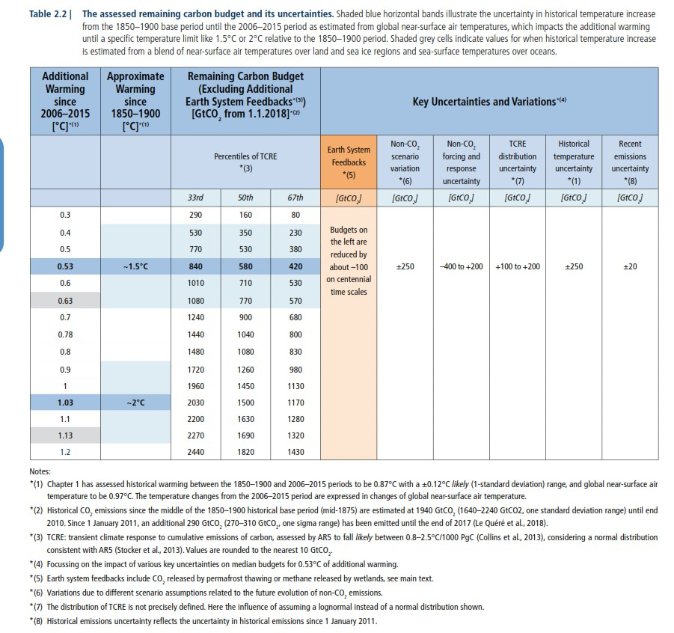

Figure 12. Overall residual carbon budgets as of 1erJanuary 2018
105. Already now, the 2018 data for the overall residual carbon budget is outdated. Indeed, the AR6.I of August 2021 has revised them downwards. This is shown in the following table (Figure 13). It appears that in order to have one chance out of two (50% chance of success) to respect the limit of dangerous warming, the global residual carbon budget of 580 GtCO₂ has been revised to 500 GtCO₂ . To have a two out of three chance of meeting the dangerous warming limit (67% chance of success), the global residual carbon budget of 420 GtCO ₂was lowered to 400 GtCO ₂.
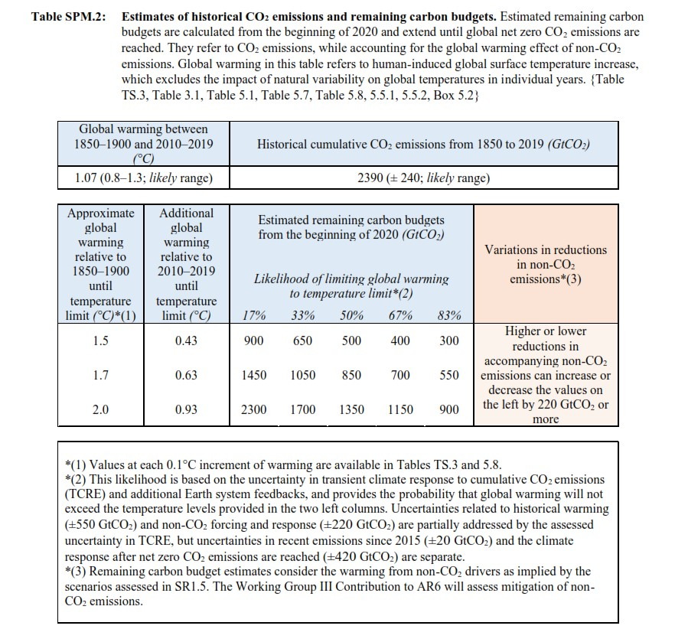

Figure 13. Overall residual carbon budgets at the beginning of 2020.
- This residual global carbon budget is a common good for all humanity.
In order to respect the share of others, one must specify one's own.
Since the overall residual carbon budget is a figure, there is a way to do this sharing. In fact, any quantified data can be shared. The only requirement is to choose a distribution key, to justify the choice, and to communicate with total transparency in this regard so that the choice and its justification can be verified by others.
- In order to establish Belgium's share, the conclusion is based on the data of the IPCC Special Report of 2018, not the AR6.I of 2021. The sharing of the residual global carbon budget indicated therein was done by a group of experts working under the direction of Mr. Jean-Pascal van Ypersele, Professor of Climatology at UCLouvain and Vice-Chair of the IPCC from 2008 to 2015. Their work is available in a scientific report dated May 2019, attached to the present request (Exhibit C.11).
- Based on the global residual carbon budget of the IPCC Special Report 2018, "between 420 and 570 GtCO ₂, this group of experts calculated the Belgian residual carbon budget by trying two allocation keys.
Let us look at the relevant passages in the report.
Mr. van Ypersele's team first sought to divide the overall residual carbon budget in terms of inhabitants (Exhibit C.1, p. 120). We quote, "Given an equal split per capita (based on population), we obtain a residual budget of between 630 and 850 MtCO₂ for Belgium as of 2018 (6 to 9 times our current ₂annual CO emissions level)." The budget obtained with this first distribution key, would have been 'eaten up in 2024, or even 2027, if nothing changes quickly.
Another sharing criterion was considered. We quote again: "Taking into account a distribution based on current emissions (countries with more polluting infrastructures are allocated a higher percentage in order to avoid losing more fixed assets), we obtain a residual budget of between 990 and 1340 MtCO₂for Belgium from 2018 onwards (10 to 14 times our current level of ₂annual CO emissions)" The budget obtained with this second distribution key, which gives more to those who are already taking a lot, will be 'eaten up' in 2028, or even 2031, if nothing changes quickly.
It is the second distribution key that has been retained. It leads to a Belgian residual carbon budget that is not equitable from a global development point of view because it is not aligned with the principle of common but differentiated responsibilities. From this overly generous budget, the lower limit was retained: 990 MtCO ₂
We have stressed that it is essential to be transparent about the distribution key used. The report quoted is so.
109. With this Belgian residual carbon budget in mind, the Expert Group then checked which CO emission reduction trajectory would ₂allow it to be met, starting from the country's emission level in 2018 as established by the competent federal state administration. The following graph shows their results. In passing, they compare these results with the emission reduction trajectories foreseen in the draft Integrated National Energy and Climate Plan prepared at the beginning of 2019 to meet the requirements of the European Union's Governance Regulation 2018/1999. The gap is huge.
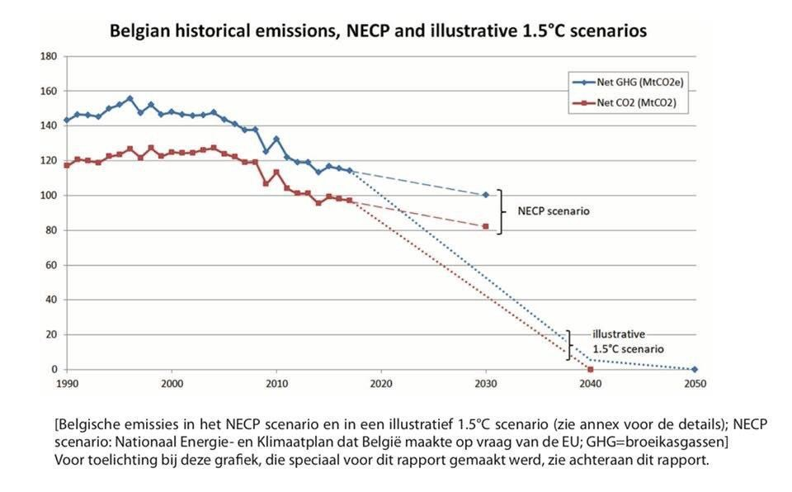

Figure 14. Belgian emission reductions.
They point out that this reduction scenario, which leads to zero net CO emissions₂in 2040, allows for a residual carbon budget of "about 1,000 MtCO ₂
110. Their results imply that by 2030, a 65% reduction in CO₂ must be achieved, in accordance with a linear reduction trajectory. This can be seen in the graph below:
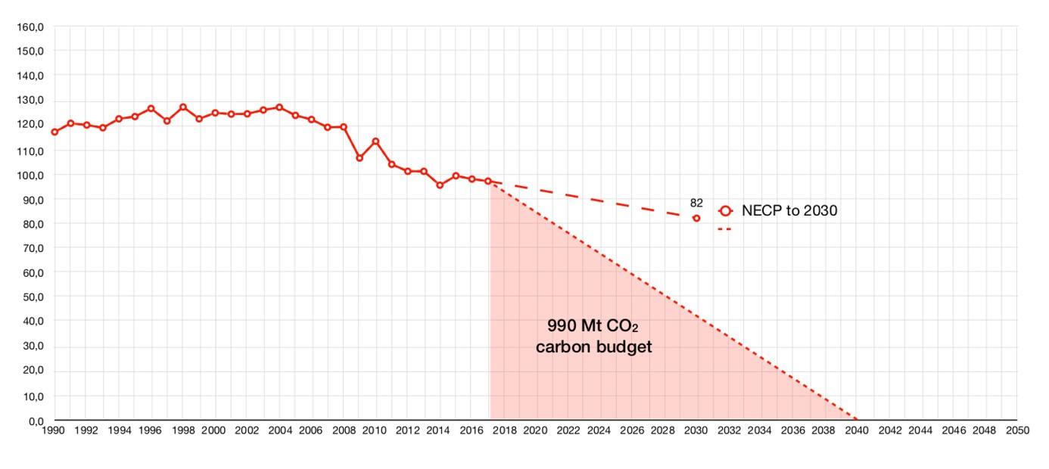

Figure 15. Belgium's residual carbon budget: linear reduction path
111. The 65% reduction in CO emissions₂ by 2030 is extremely reasonable and should be understood as a bare minimum for the country to do its part.
Indeed:
1/ The global residual carbon budget on which the Belgian residual carbon budget and emission reduction pathway are based is the global residual carbon budget put forward by the IPCC in 2018. However, in its AR6.I of 2021, the IPCC revised this budget downwards. The national residual carbon budget is currently smaller than the one used to establish the emissions reduction trajectory and the resulting 65% reduction in 2030.
2/ The % of 65% in 2030 put forward by the Expert Group is based on a Belgian residual carbon budget that was calculated on the basis of a distribution key that ignores the principle of common but differentiated responsibility enshrined in the UNFCCC and confirmed by the Paris Agreement. On the basis of this distribution key, Belgium's share is too generous.
On the basis of the factual data, established by the IPCC and recognised by the international world community, that the limit of dangerous warming is "well below 2°C" and must be understood as 1.5°C, and of the resulting residual global and Belgian carbon budgets, a 65% reduction in CO emissions₂from the Belgian territory over 2030 is truly a strict minimum
- Several European countries have already adopted similar or more stringent emission reduction targets.
    - Finland aims for zero net GHG emissions by 2035 (Exhibit P.14) ;
    - Denmark's Climate Law of December 6, 2019 calls for a 70% reduction in GHG emissions over 2030 (Exhibit L.22) ;
    - The UK has revised upwards the 57% GHG emission reduction target for 2030 in its Climate Change Act. The revised percentage in the Act is a reduction of at least 78% by 2035⁸³;
    - Following the recent judgment of the Bundesverfassungsgericht, which pinpointed the disregard of the intergenerational dimension of climate policy by the federal climate law ('Bundesklimaschutzgesetz')⁸⁴, Germany has revised upwards the percentage of GHG emissions reduction for 2030 inscribed in this law. At the end of August 2021, this percentage increased from 55% to at least 65%. ⁸⁵
- Given the critical importance of the linearity of the emissions reduction pathway, explained above, it is useful to specify the percentages of emissions reductions from now to 2030 that correspond to this linearity. We draw these from the GHG emission reduction series that are part of the Expert Panel's graph. They tell us in MtCO amounts ₂and percent reductions relative to 1990 what the Expert Panel's graph visually communicates.

  - See https://www.gov.uk/government/news/uk-enshrines-new-target-in-law-to-slash-emissions-by-78-by-2035 . See also https://www.gov.uk/government/news/uk-sets-ambitious-new-climate-target-ahead-of-un summit
  - Bundesverfassungsgericht, Order of 24 March 2021.
See https://www.bundesverfassungsgericht.de/SharedDocs/Entscheidungen/EN/2021/03/rs20210324_1bvr265618en
.html .
See also https://www.bundesverfassungsgericht.de/SharedDocs/Pressemitteilungen/EN/2021/bvg21 031.html
  - See also https://www.reuters.com/business/environment/germany-raise-2030-co2-emissions-reduction-target-65 spiegel-2021-05-05/

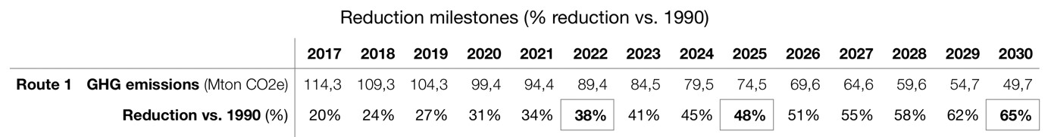

Figure 16. Table of reductions by 2030 with a 65% cap in 2030
Adding this milestone of 48% in 2025 to the reduction target of 65% over 2030, offers a guarantee for the linearity of the reduction trajectory over 2030. As already mentioned, this linearity is essential for respecting the Belgian residual carbon budget. Moreover, a reduction of GHG emissions of at least 48% by 2025 simply offers a guarantee of the possibility to reach a reduction of at least 65% by 2030.
- The 2030 reduction target is essential in that it includes a guarantee that the goal of zero net emissions can be achieved in time. We will return to this later.
- In conclusion, the standard of behaviour that should be applied in the future by the respondents in order to comply with Articles 2 and 8 of the ECHR and Article 1382 of the Civil Code is the following:

to reduce or cause to be reduced the overall volume of annual greenhouse gas emissions from the Belgian territory in such a way as to achieve by 2025 a reduction of at least 48% compared to the level in 1990;
to reduce or cause to be reduced the overall volume of annual greenhouse gas emissions from the Belgian territory in such a way as to achieve in 2030 a reduction of at least 65% compared to the level in 1990.
- Already in 2019, on the basis of the IPCC Special Report SR1.5°C of 2018, the above-mentioned Expert Group estimates that "in order to reach the 1.5°C limit, Belgium and Europe must aim for zero net CO2 emissions by 2040".₂ As CO emissions ₂are only increasing, even in 2021, the global residual budget that allows us to respect with a useful probability the threshold of 1.5° or even the threshold "well below" 2°C, is decreasing more and more rapidly. Thus, the moment when zero net CO emissions will have to be reached ₂is getting closer and closer. As a result, the conclusion is that zero net GHG emissions in 2050 is not a standard of behaviour under Articles 2 and 8 of the ECHR and Article 1382 of the Civil Code. It is highly likely that this time horizon will be reviewed, in favour of a stricter time horizon. However, the 48% and 65% reductions to be achieved at least by 2025 and 2030 are still absolutely essential to preserve the chance of reaching zero net emissions in due course. This is one more reason why they are, without doubt, a minimum minimorum to be achieved.
- As a complement, we add a graph showing the CO consumption₂ of Belgium in the hypothesis that we would pursue a linear trajectory of emissions reduction over 2030 and 2050 similar to the one adopted by the European Union in its Climate Law of June 30, 2021, i.e. -55% in 2030 and net zero in 2050. It appears unequivocally that, under this trajectory, even if linear, the country's residual carbon budget will be largely exceeded.

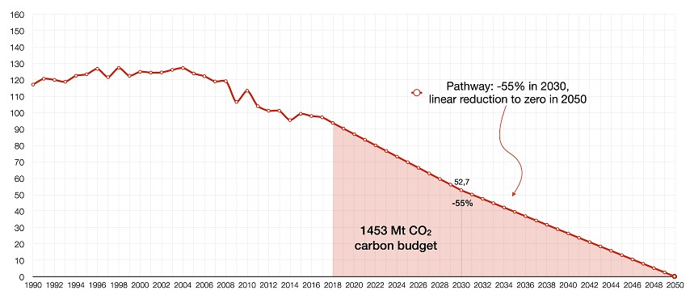

Figure 17. Assumption of a linear reduction trajectory of 55% in 2030 and net zero in 2050

C. In concreto, what has been the conduct of the Respondents? For the past: 2020
118. Based on the GHG emission inventories that Belgium submits annually to the UNFCCC secretariat, the country's GHG emission reductions can be summarised as follows
- 2010 : -7,5%
- 2011 : -16,4% - 2012 : -19%
- 2014 : -23,5%
- 2015 : -19,7%
- 2016 : -19,2%
- 2017 : -21,9% - 2018 : -17,9% - 2019 : -18,8%. 119. Since 2007, Belgium, which has participated in and contributed to all the COP work and decisions, has known that a 25% reduction by 2020 was a strict minimum for Annex I countries in general in the light of knowledge at the time. It also knew that in the 25-40% range, its "share" was more in the 40% range, for the reasons mentioned above.
Far from doing so, Belgium has systematically placed itself on the side of mediocrity. The figures bear this out.
Worse still, it has constantly taken refuge behind the targets that the European Union has set for 2020. This was despite the fact that the European Union itself recognised the inadequacy of its targets. All the States Parties to the UNFCCC knew that these targets did not make it possible to achieve the ultimate goal of 2050. It was up to them, individually, to take the necessary measures to achieve it.
The figures also show that the emission reduction trajectory followed is not linear. On this point too, Belgium has placed itself on the side of mediocrity.
The Belgian climate policy for 2020 is therefore in clear violation of the standard of conduct imposed by Articles 2 and 8 of the ECHR and Article 1382 of the Civil Code.
- The judgment under appeal found that the Belgian authorities were at fault, basing themselves exclusively on the binding obligations to reduce GHG emissions enshrined in international, European and national/intra-Belgian climate law.
In so doing, the Court of First Instance erred in law. The standard of conduct binding on the Belgian authorities is not the same as the standards of climate law referred to. It is defined in the light of the respondents' knowledge, for too long already, of the danger and of the concrete measures to be taken to avoid or limit that danger.
This knowledge is based on the best scientific knowledge on the subject, which has been included in the IPCC reports and has been explicitly adopted, supported and repeated by the world political community, including Belgium.
This climate science is not in dispute. On the contrary, it is the subject of a particularly broad and established consensus within the international community and is the reference for all policy makers.
- The climate emergency is here. Every additional particle of GHG in the atmosphere brings us closer to dangerous global warming, with points of no return. The behaviour of the parties involved must be analysed in the light of the serious danger that the inhabitants of Belgium, like the rest of humanity, are facing and the urgent need to act.

For the future: 2030
- The behavioural standard based on the global residual CO budget ₂established by the IPCC on the basis of the threshold of dangerous warming anchored in the Paris Agreement, requires Belgium to reduce its GHG emissions by at least 65% by 2030, along a minimally linear trajectory, and this to preserve the possibility of reaching net zero emissions in due course, most likely before 2050.
However, as things stand, there is no indication that the Respondents have taken steps to achieve this. On the contrary. There are serious and unequivocal indications that they are threatening to disregard the standard of conduct required of them under Articles 2 and 8 of the ECHR and Article 1382 of the Civil Code.
At the level of political will, the following elements should be noted.
  - The Flemish Region has committed itself to a reduction of GHG emissions of 32.5% (compared to 1990) by 2030 within the framework of the outdated EU targets and the competent minister, Ms Demir, declared shortly before the Glasgow Summit (COP26, 31 October - 12 November 2021) that for Flanders, 35% would be the reduction target for 2030. This position was qualified shortly afterwards, in the middle of the Summit. The Flemish Government will aim for a 40% reduction of GHG emissions by 2030.
  - The Walloon government is pursuing a 55% reduction in GHG emissions (compared to 1990) by 2030. The plan is being developed in two stages, the second of which will only be ready by the end of 2022. At the moment, the results that can already be envisaged amount to a reduction of 37% by 2030.
  - The Brussels-Capital Region committed itself in 2019 to reducing its emissions by at least 40% (compared to 1990) by 2030. This objective has been maintained to date.

In terms of factual forecasts, we can only mention a recent report by the Federal Planning Bureau. This report sheds light on the temporary impact (2023-2026) of gas-fired power plants that will have to take over, to a certain extent, from the nuclear power plants that will be gradually closed. It projects that the country's GHG emissions will have decreased by 17% from their 1990 level by 2026. How do we get from there to 65% by 2030?
In conclusion
- It follows from the above that the respondents have not only violated the standard of conduct imposed by Articles 2 and 8 of the ECHR and Article 1382 of the Civil Code with respect to the 2020 reduction targets, but that there is also no indication that they have taken and will take steps to remedy the situation by 2030.

Second grievance:
In the present case, the judge can impose the requested emission reduction orders without violating the principle of separation of powers
V.2.1 Reminder and criticism of the judgment
- The Tribunal stated at page 45 of the judgment a quo:
The Court of Appeal has held that "it is settled that the judiciary has jurisdiction to prevent or remedy any wrongful infringement of a subjective right by a public authority in the exercise of its discretionary power".
It should be noted that the Tribunal did not challenge the principle of its power to issue injunctions. This point in the judgment under review must be retained.
On the other hand, it was with regard to the principle of the separation of powers that the Court of First Instance considered that the application for an injunction could not be granted.
- In fact, to justify its rejection of the application for injunctions, the Court of First Instance relied on the premise that "the judge cannot determine the content of the obligations of a public authority and thus deprive it of its discretion" without "infringing the principle of the separation of powers. And again: "In other words, if the judiciary is competent to establish the fault committed by the public authority, even in the exercise of its discretionary power, it cannot, on this occasion, deprive the latter of its political freedom or substitute itself for it. The judiciary may not assess the appropriateness of the action of the public authority in the exercise of its jurisdiction, nor may it itself exercise the discretionary power that belongs to that public authority."
- Having set out that premise, the Tribunal undertakes to ascertain whether the injunctions sought do not lead it to substitute itself for the authorities in the exercise of a discretionary power and, in so doing, to violate the principle of the separation of powers.
First, the Court of First Instance examines whether binding obligations under international, European or national climate law directly require Belgium to reduce GHG emissions from Belgian territory to the extent of the percentages covered by the injunctions sought. This is not the case.
Second, the Tribunal considers the scientific argument that supports the requested injunctions, namely the Panel's report already mentioned in this application. The IPCC basis for this report, which roots it in the best available climate science validated by the entire world community, is not noted. On the other hand, the judgment insists that such a report does not constitute "a source of legally binding obligation".
The conclusion that concludes all of the developments is that there is a discretionary power at issue in which the judiciary cannot interfere. The Court concludes: "The request for an injunction formulated by the plaintiffs will therefore be declared unfounded" .
- The appellants consider that, in the present case, the principle of the separation of powers has been wrongly invoked; that the Tribunal should have declared itself competent to impose the injunctions sought. Indeed, contrary to the Tribunal's finding, these injunctions do not violate the principle of separation of powers, as will be demonstrated below.
The appellants therefore ask the Court to remedy the wrongful infringement of their subjective rights and, consequently, to impose injunctions to reduce the GHG emissions emitted from Belgian territory.
V.2.2 The applicable principles
- It will be explained in the following lines that the constitutional principle of the separation of powers does not interfere with the injunctive power of the judge insofar as :
  - The authorities have no discretion as to the principle of conduct, the measure imposed being the only one that can be taken to put an end to their illegal conduct;
  - The injunction merely imposes the principle of the conduct to be adopted, the public authority remaining free in the choice of enforcement measures;
  - The injunction is intended to provide an effective remedy for the violation of fundamental rights enshrined in the ECHR and for the violation of rights protected by the Aarhus Convention.
A. The principle of separation of powers is not violated where the authorities have no discretion as to the principle of conduct to be adopted, the measure imposed being the only one that can be taken to put an end to their illegal conduct
- In a judgment of 29 January 2021, the Dutch-speaking Court of First Instance in Brussels ruled as follows
"The constitutional principle of separation of powers prohibits a judge from compelling the administration to take a certain action if it does not appear that this action is the only one that can be taken to remedy the injury in kind without violating the law." (free translation - emphasis added).
Already this court had ruled in the same direction. In a decision of October 10, 2018, it indeed held that:
"The freedom of action of the regulatory authority must be respected, which means that the judge cannot oblige the authority to take (or not to take) a particular measure if it appears that this measure is not the only way for the authority to achieve legality" (free translation - emphasis added) .
- These judgments echo the case law of the Court of Cassation.
Thus, the Court held in a September 4, 2014 ruling that:
"(...) when several legal solutions are possible to achieve reparation in kind, the judge cannot decide for the authority which of these solutions should be adopted; it is not for the judiciary to assess the desirability of adopting one of these solutions rather than the other; (...)"¹⁰³.
B. The principle of separation of powers is not violated when the judge imposes the principle of a behaviour to be adopted without specifying the measures of execution
- The doctrine emphasizes that the existence of a discretionary power on the part of the public authority "does not absolutely prevent an injunction from being issued. The latter may concern only the principle of a behaviour to be adopted, the condemned administration determining the modalities of execution"¹⁰⁴.
- Indeed, it is established case law of the Court of Cassation that the principle of the separation of powers would be violated where the judge requires the legislative/executive power to take certain measures, specifying what type of measures they are and what their content should be.
- Thus, in a decision of 4 March 2004, the Court of Cassation explained the violation of the principle of the separation of powers by the precision and detail with which the judge condemned the public authorities to act:
"...] by determining in a precise and technically detailed manner in the operative part of the decision in which the public authorities can avoid infringement of the defendants' subjective rights, the judges of appeal substituted themselves for the executive power and thus violated the constitutional principle of the separation of powers¹⁰⁵.

The Cour de Cassation (French Supreme Court) agrees with this in a decision dated 3 January 2008:

"The judiciary has no business interfering in the assessment of the appropriateness of the administrative decision on the dispersal of aircraft flights, nor in substituting its own decision for that of the authorities.
By ordering the authorities to intervene in this case and by laying down the criteria on the basis of which that intervention should take place, the appeal judges unlawfully substituted their assessment for that of the applicant.
In determining the manner in which the authorities are to intervene in order to determine the policy relating to the national airport, the judgment under appeal infringes the general legal principle of the separation of powers and all the provisions relied on in the plea¹⁰⁶.

nemen wanneer blijkt dat die maatregel niet de enige wijze is waarmee de overheid de wettelijkheid kan realiseren ".
- Cass. C.12.0535.F of 4 September 2014 available at http://jure.juridat.just.fgov.be
- B. JADOT, "Les pouvoirs du juge judiciaire à l'égard de l'administration: le pouvoir d'injonction et la réparation en nature" in La responsabilité des pouvoirs publics, Brussels, Bruylant, 1991, pp.450 and 452.
- Cass. (1st ch.), 4 March 2004, R.G. n° C.03.0346.N;C.03.0448.N.
- Cass. 3 January 2008, R.G. n° C.06.0322.N.
In a judgment of 27 October 2006, the Court held that the judiciary may order the executive to make good damage caused by its negligence without depriving the executive of its freedom of appreciation as to the measures to be adopted to make good the damage.
134. The lower courts and tribunals follow this jurisprudence. The Court of First Instance of Liège, for example, ruling on the overcrowding of the Lantin prison, retained the same premises in its judgment of 9 October 2018:
The Court of Appeal has held that "while the State may be required to take measures to reduce (such overcrowding), it is for the State to decide what measures it will adopt to that end. In a somewhat caricatured but nonetheless real way, there is nothing that allows a court to impose on the State, in order to achieve this, legislative changes tending to reduce the number of prisoners rather than to increase the capacity of prison establishments".
C. Injunctions are intended to provide an effective remedy for the violation of fundamental rights enshrined in the ECHR and for the violation of rights protected by the Aarhus Convention
135. In the present case, the judgment a quo found that the applicants' fundamental rights, in particular Articles 2 and 8 of the ECHR, were violated.
It should be recalled that Article 1er of the ECHR provides that "States shall secure to everyone within their jurisdiction the rights and freedoms defined in Section I of the Convention".

There is no doubt that national judges are the primary guarantors of respect for the rights enshrined in the ECHR. According to the European Court of Human Rights, "the courts must examine rigorously the pleas relating to the 'rights and freedoms' guaranteed by the Convention before them and this is a corollary of the principle of subsidiarity".

The Belgian doctrine recalls in this sense that :
"The national judge, because of his geographical proximity, is best placed to offer the most adequate protection of the fundamental rights at issue before him. G. Rosoux argues that ''national protection must thus precede international protection''.
- We should also recall Article 13 of the ECHR, which enshrines the "Right to an effective remedy" in the following terms: "Everyone whose rights and freedoms as set forth in this Convention are violated shall be entitled to an effective remedy before a national authority notwithstanding that the violation has been committed by persons acting in an official capacity."
- Thus, in the event of a violation of fundamental rights enshrined in the European Convention on Human Rights, the national court is necessarily empowered to order the authorities to take appropriate measures. The effectiveness of the protection of the rights guaranteed by the ECHR depends on this.
- Also relevant to the violation of the standard of care in Article 1382 of the Civil Code is Article 9.4 of the Aarhus Convention, which also emphasizes the need for an effective remedy: "In addition, and without prejudice to paragraph 1, the [judicial] procedures referred to in paragraphs 1, 2 and 3 above shall provide adequate and effective remedies, including injunctive relief where appropriate, and shall be objective, fair and expeditious and not prohibitively expensive.
V.2.3 Application in this case
- The concluding parties consider that the constitutional principle of separation of powers allows them to ask your Court to oblige the respondents to reduce their GHG emissions in a certain way. Indeed:
  - In the present case, the respondents have no discretion as to the principle of conduct to be adopted, the GES injunctions sought being the only means for the authorities to achieve legality (A),
  - Respondents remain free to choose the means to achieve the requested GHG emission reductions (B), and
  - injunctions are the only effective remedy for the violation of fundamental rights guaranteed by Articles 2 and 8 of the ECHR (C) and for the violation of rights protected by the Aarhus Convention.
A. There is no margin of appreciation in this case: these injunctions are the only measures enabling the authorities to achieve legality
- As a reminder, the injunctions sought on appeal are the following two injunctions:
  - to reduce or cause to be reduced the overall volume of annual greenhouse gas emissions from the Belgian territory in such a way as to achieve by 2025 a reduction of at least 48% compared to the level in 1990;
  - to reduce or cause to be reduced the overall volume of annual greenhouse gas emissions from the Belgian territory in such a way as to achieve in 2030 a reduction of at least 65% compared to the level in 1990.
- As demonstrated above, in establishing the standard of behaviour imposed by Articles 2 and 8 of the ECHR and by Article 1383 of the Civil Code, the injunctions requested correspond to a minimum minimorum for the country to do its part to prevent and effectively limit dangerous warming, understood as warming "well below 2°" and tending towards 1.5°C. This threshold not to be exceeded was specified by the IPCC and was formally enshrined in 2015 by the Paris Agreement
In light of the current climate emergency and the very limited overall residual carbon budget, there is simply no discretion left to determine minimum GHG reduction targets for respondents.
Only appropriate GHG emission reductions can prevent dangerous global warming. There is no other way to stop the violations of Articles 2 and 8 ECHR and Article 1382 of the Civil Code that the Respondents have committed in pursuing their climate policies and, in all likelihood, will continue to commit.
B. Respondents remain free to choose the means to achieve GHG emission reductions
142. As a reminder, the requested injunction concerns a minimum result to be achieved in order to avoid the violation of human rights and the respect of the standard of conduct set out in Article 1382 of the Civil Code. This result takes the form of minimum thresholds for reducing GHG emissions within a certain period of time. The judge is not being asked to impose the precise means of achieving these reduction thresholds. The respondents retain complete freedom to choose the means to be implemented and the methods of implementation.
C. Failure to issue an injunction would result in a violation of the right to an effective remedy
- By deciding that the respondents had violated Articles 2 and 8 of the ECHR and had also committed a fault within the meaning of Article 1382 of the Civil Code, but by refusing to impose the requested injunctions for the future, the judgment under appeal not only misapplied the principle of the separation of powers but also infringed the right to an effective remedy, guaranteed by Article 13 of the ECHR and Article 9.4 of the Aarhus Convention.
- Pursuant to Article 13 of the ECHR and Article 9.4 of the Aarhus Convention, this Court must offer on appeal the most adequate protection of the subjective rights at issue before it, and the only way to do so is to impose the injunctions sought and thus to order the respondents to reduce their GHG emissions as developed by the appellants
- In the present case, the injunctions sought are essential to respect the subjective rights of the appellants in the light of the particularly negligent attitude of the respondents, both in the past and in the follow-up to the judgment under appeal.
- As a reminder, Belgium's GHG emission reductions over 2020 can be summarized as follows:
  - 2010 : -7,5%
  - 2011 : -16,4% - 2012 : -19%
  - 2014 : -23,5%
  - 2015 : -19,7%
  - 2016 : -19,2%
  - 2017 : -21,9%
  - 2018 : -17,9% - 2019 : -18,8%.
It is clear that emission reductions have stagnated since 2011, with no significant progress, and remain well below what the behavioural standard required. As regards the 2030 horizon, no concrete response to the challenges has been made following the judgment of 17 June 2021. Contrast this with Germany, where a 24 March 2021 ruling by the Bundesverfassungsgericht found that a federal climate law that mandated a 55% reduction in GHG emissions by 2030 was unconstitutional in that it violated the right to life and physical integrity and the right to property of young people and future generations by postponing too many emission reductions until the future¹¹¹. In response to this finding of violation of fundamental rights, the federal government tabled within two weeks an amendment to the law that provides for an increase in the GHG reduction by 2030 from 55% to 65% and, in addition, zero net emissions in 2045. This amendment came into force on August 31, 2021. ¹¹²
148. The disturbing attitude of the Respondents in view of the seriousness and urgency of the situation underlines the need for injunctions to ensure that the Appellants' remedy is an effective one. In this case, the injunctions sought are the only measure that provides an effective remedy.
Other grievances
V.3.1 The UNFCCC has not been amended by the Kyoto Protocol and the Paris Agreement; its original wording remains unchanged
A. Review and criticism of the judgment under review
149. In its statement of the factual background to the dispute, the judgment under review refers to the UNFCCC (1992), the Kyoto Protocol (1997) and the Paris Agreement (2015). In situating the Paris Agreement, the judgment characterizes it as an amendment to the UNFCCC, more specifically a second amendment to the UNFCCC, the previous one being logically the Kyoto Protocol: "On 12 December 2015, at COP-21 held in Paris, the member states of the Framework Convention adopted the Paris Agreement by which the UNFCCC was once again amended." ¹¹³
This understanding of the Kyoto Protocol and the Paris Agreement is legally flawed. The text of the Framework Convention is unchanged to this day, especially with regard to its Article 2, which states the ultimate goal of the Framework Convention: to prevent dangerous anthropogenic global warming.
The error in law committed is such as to diminish the importance of the UNFCCC, in particular its Article 2, and to emphasize the commitments embodied in the Protocol and the Agreement. The Appellants therefore consider that it is detrimental to their case in that it is likely to facilitate the error in law committed by the Tribunal when it exclusively took into account binding obligations under international and other climate law as a reference for assessing the legality of the Respondents' conduct,

¹¹¹ Bundesverfassungsgericht, Order of 24 March 2021.
See https://www.bundesverfassungsgericht.de/SharedDocs/Entscheidungen/EN/2021/03/rs20210324_1bvr265618en
.html .
See also https://www.bundesverfassungsgericht.de/SharedDocs/Pressemitteilungen/EN/2021/bvg21-031.html. See¹¹² ¹¹³https://www.bundesregierung.de/breg-de/themen/klimaschutz/climate-change-act-2021-1936846 Judgement undertaken, p. 26.
confusing the standard of behaviour imposed by Articles 2 and 8 of the ECHR and by Article 1382 of the Civil Code with positive law.
B. Applicable principles and their application in this case
- International public law characterizes the UNFCCC, the Kyoto Protocol and the Paris Agreement as three separate treaties, which coexist on an equal footing even though the Kyoto Protocol and the Paris Agreement align with the UNFCCC by referring to it in their preambles and provisions. Their formal legal relationship is not like that of successive national laws where the most recent one modifies the previous one. Nor is it to be understood as that between a law and an implementing order.
With regard to the Kyoto Protocol in particular, it should be stressed that it is not a modifying protocol like, for example, the 1996 Protocol to the 1972 Convention on the Prevention of Marine Pollution by Dumping of Wastes and Other Matter, which, in its Article 23, states that it modifies the 1972 Convention for those States Parties to the Protocol that are also Parties to the Convention.
- In this case, Article 2 of the UNFCCC remains unchanged as the basis for international climate governance. The notion of dangerous warming is at the heart of the work of the IPCC and the COPs. The knowledge of the threshold of a dangerous warming and the knowledge of the measures to avoid and limit such a warming determine the standard of care of national authorities worldwide and also in Belgium.
V.3.2 The court was wrong to consider that it was required to exercise only marginal control over the authorities' compliance with the standard of conduct imposed by Articles 2 and 8 of the ECHR and by Article 1382 of the Civil Code
A. Review and criticism of the judgment under review
- In specifying the legal framework within which it must assess the responsibility of the public authorities, the court considered that it must exercise "a necessarily marginal control" thus avoiding "substituting its assessment for that of the legislator", respecting "the guidelines laid down by the case law of the Court of Cassation". ¹¹⁵
- Similarly, the judgment in question characterizes its review of the public authorities' compliance with the obligations arising from Articles 2 and 8 of the ECHR as a "marginal review".
- Both with regard to the standard of conduct laid down in article 1382 of the Civil Code and with regard to the standard of conduct imposed by articles 2 and 8 of the ECHR, this view constitutes an error in law which is detrimental to the appellants' case. Indeed, the appellants are entitled to a judicial review of a different quality, which goes further and is more comprehensive than a marginal review.
B. Applicable principles and their application in this case
- The key criterion for the extra-contractual liability of public authorities in Belgian law, enshrined in the case law of the Court of Cassation, is that of an ordinarily prudent and diligent public authority in the same circumstances of time and place. This is the criterion to be applied, the extent of the control to be carried out. It does not impose a 'marginal control' style restriction. The test is applied in the light of the circumstances of the case and that control is fully exercised.
- The very idea that the judge would exercise marginal control over the right to life enshrined in Article 2 of the ECHR is shocking. Even at the level of the control exercised by the European Court of Human Rights, this fundamental right escapes the theory of the margin of appreciation which the Court imposes on itself and which allows the States Parties to the ECHR to apply certain rights according to local circumstances. Like the prohibition of torture and slavery, it is one of the so-called 'Notstandsfeste' rights, which are so fundamental that no margin of appreciation is allowed.
The fundamental right enshrined in Article 8 of the ECHR, on the other hand, is one of the fundamental rights for which the European Court of Human Rights uses the theory of the margin of appreciation of the States Parties in its own case law. However, this theory does not apply to the national judge, who is the first judge to ensure that the rights enshrined in the ECHR are respected; it is specific to the control exercised by the European Court. According to the European Court, "the courts must examine rigorously the pleas relating to the "rights and freedoms" guaranteed by the Convention before them and that this is a corollary of the principle of subsidiarity". According to the Court, "The theory of the margin of appreciation has always been seen as a means of defining the relationship between the domestic authorities and the Court. This theory does not apply in the same way to the relationship between the organs of the State at the domestic level". There is no question at the level of national courts and tribunals of a review that would in principle be only marginal.
V.3.3 The court wrongly considered that mitigation and adaptation are two adequate responses to global warming and that 450 ppm of GHGs is a limit that should not be exceeded before 2100
- In examining the obligations arising from Articles 2 and 8 of the ECHR in relation to the measures to be taken, the Court considers that "appropriate" measures may "be of two kinds: either so-called mitigating measures, which are designed to prevent the danger from materialising, or so-called adaptation measures, which are designed to cushion or attenuate its effects".
Where this consideration equates mitigation and adaptation, it is factually incorrect. As the IPCC's work has shown for many years, the only measures that make a real difference are mitigation measures: reductions in GHG emissions, primarily CO ₂
- Furthermore, a statement in the judgment concerning the acceptable limit of GHG concentration in the atmosphere is also factually incorrect. This is the following passage: "The scientific community agrees on the need to contain the concentration of GHGs at 450 ppm by 2100, whereas currently the concentration of GHGs is already above 400 ppm." As mentioned in the narrative, the 450 ppm limit relates to a warming of 2°C , a threshold formally abandoned in the Paris Agreement (2015), following a gradual pathway in that direction from 2009 . The threshold of "well below 2°C" and moving towards 1.5°C enshrined in the Paris Agreement comes with a maximum concentration of 430 ppm and the residual CO budgets ₂that follow, as explained above. This factual error is along the same lines as the above error: it gives the impression that there is not so much urgency when in truth there is.
- The standard of conduct imposed by Articles 2 and 8 of the ECHR and Article 1382 of the Civil Code is typically assessed in the light of the circumstances of the case. By the distortion they create of the measures to be considered and of the window of opportunity still available in time to do what is necessary, two key aspects of the case submitted to the Tribunal, the errors of fact noted have a negative impact on the appellants' case.
Both of those errors of fact are also such as to have facilitated the erroneous position that the injunctions sought could not be imposed in the light of the separation of powers, in particular in the light of the margin of discretion alleged to exist.
Therefore, the appellants consider that they have been prejudiced.
VI. On-call duty
- Given the extreme urgency of the requested GHG emission reductions that allow the country to do its part to avoid or limit dangerous global warming, and in light of the grossly inadequate governance that the Respondents have demonstrated for decades, the Appellants request that the injunctions be imposed under penalty. More specifically, they request that the respondents be ordered jointly and severally, or in default of each other, to pay to the first appellant, Klimaatzaak vzw, a penalty of €1,000,000 per month of delay in reaching the objective imposed for 2025 and the objective imposed for 2030, starting on 1 ^{er}August of the year following the deadlines (i.e., in 2026 and 2031). The choice of the ^{er}August 1 date is explained below.
- The amount of the periodic penalty payments requested is reasonable. As is well explained in a Dutch academic article dealing with the question of imposing a penalty payment on the Dutch State in the Urgenda case, the amount of the penalty payment must make non-compliance more onerous for the condemned party than compliance. Compliance then becomes the only economically rational option. The authors of this publication estimate at 10 million US dollars the "reasonable" annual amount that could "induce" the Dutch State to comply with the Urgenda judgment, and also emphasize that this amount would not constitute "a serious burden on the State budget". The penalty payments requested by the appellants to support the enforcement of the injunctions ordering GHG emission reductions over 2025 and 2030 are in a similar range.
- In this case, we request that the annual reporting of Belgium's GHG emissions to the European Commission be used to monitor compliance with the injunctions. This reporting is done automatically every year, by 31 July at the latest, in accordance with Article 26.2 of Regulation (EU) 2018/1999. This reporting mechanism allows the EU to meet its annual reporting obligation on GHG emissions as a party to the UNFCCC.
Article 26.2 of Regulation (EU) 2018/1999 reads as follows:
« 2. By 31 July 2021, and every year thereafter (year X), Member States shall submit to the Commission their proxy greenhouse gas inventories for year X-1.
(…)»
The reports must be submitted to the first appellant, Klimaatzaak vzw, on the same day that they are submitted to the European Commission. In the event that the respondents do not communicate these emission reports by 31 July 2026 (for 2025) and/or by 31 July 2031 (for 2030) at the latest, the appellants request that they be ordered, jointly and severally or in default of each other, to pay a penalty of €10,000 per day of delay in communication.
163. The appellants also request that you declare that Klimaatzaak vzw undertakes to allocate the accrued penalty payments in full in accordance with its corporate purpose.

- Costs
164. The appellants request that the respondents be ordered to pay the procedural costs of the first instance and of the appeal in the amount of €3,120 (€1,560 x 2), consisting of the procedural costs which cannot be valued in money and which will be adjusted on 1 ^{er}June 2021.

- Device

FOR THESE REASONS
WITHOUT PREJUDICE TO ANY GENERAL RESERVATIONS AND WITHOUT PREJUDICIAL RECOGNITION
PLEASES THE BRUSSELS COURT OF APPEAL to declare the present appeal admissible and well-founded and thus :
1° - Partially amend the judgment under appeal, except for :
  - the judgment that the action is admissible in respect of Klimaatzaak vzw and the natural persons who are the principal claimants, listed in Annex A;
  - the judgment which finds that the voluntary intervention of the natural persons listed in Annex B is also admissible;
  - the pronouncement that, "in pursuing their climate policy, the respondents did not behave like normally prudent and diligent authorities, which constitutes a fault within the meaning of Article 1382 of the Civil Code";
  - the pronouncement that, "in pursuing their climate policy, the respondents infringe the fundamental rights of the appellants, and more specifically Articles 2 and 8 of the ECHR, by failing to take all necessary measures to prevent the effects of climate change on the lives and privacy of the appellants";
2° - Declare that the standard of conduct imposed by Articles 2 and 8 of the ECHR and Article 1382 of the Civil Code requires the respondents to have reduced the overall volume of annual GHG emissions from Belgian territory by at least 30% by 2020, compared to 1990 levels;
3°- Find that the respondents have not reduced the overall volume of annual GHG emissions from Belgian territory by at least 30% by 2020, compared to the 1990 level;
4°- To confirm that, in pursuing their climate policy over 2020, the Respondents have violated the standard of conduct imposed by Articles 2 and 8 of the ECHR and Article 1382 of the Civil Code;
5°- To rule that the standard of conduct imposed by Articles 2 and 8 of the ECHR and Article 1382 of the Civil Code requires the Respondents to have reduced the overall volume of annual GHG emissions from the Belgian territory by at least 48% by 2025 and by at least 65% by 2030, compared to the 1990 level
6°- Find that there are serious and unequivocal indications that, in pursuing their climate policy for 2030, the Respondents risk disregarding the standard of conduct imposed by Articles 2 and 8 of the ECHR and Article 1382 of the Civil Code;
7°- Consequently, order the respondents to take the necessary measures to reduce or cause to be reduced the overall volume of annual GHG emissions from the Belgian territory so as to reach :
- At least 48% by 2025;
- At least 65% by 2030;
8°- Order the respondents to communicate to the first appellant, Klimaatzaak vzw, the GHG emission reports for 2025 and 2030 on the same day that they are communicated to the European Commission in 2026 and 2031;
9° Order the respondents, in solidum or one in default of the other, to pay to the first appellant, Klimaatzaak vzw, a penalty of €10,000 per day of delay in communicating the GHG emissions report for 2025 and the GHG emissions report for 2030;
10°- Order the Respondents jointly and severally, or one in default of the other, to pay to the first appellant, Klimaatzaak vzw, a penalty of 1,000,000 EUR per month of delay in reaching the objective imposed for 2025 and the objective imposed for 2030, and this, as from 1 ^{er}August of the year 2026 respectively 2031;
11°- Act that Klimaatzaak vzw undertakes to allocate the accrued penalty payments in full in accordance with its corporate purpose;
In any case
1° Declare the judgment to be provisionally enforceable;
2° Order the Respondents to pay all costs and expenses of the two proceedings, including the procedural damages in the amount of 2 x EUR 1,560, i.e. EUR 3,120.

For the appellants,

November 17, 2021,

Their advice,

Carole Billiet

Luc Depré

Audrey Baeyens

Linli Pan
-
Van de M
eulebroeke

Camille de Bueger

Gautier Rolland

IX. List of diagrams
Figure 1. CO concentrations₂ in the atmosphere over the past 800,000 years 13
Figure 2. Global warming is due to human activity and has been increasing drastically since 1850, especially 1970 14
Figure 3. Total annual anthropogenic GHG emissions by gas group from 1970 to 2010 15
Figure 4. 1750-2011: Cumulative CO ₂ 15 emissions
Figure 5: Relationship between global warming and cumulative CO₂and GHG emissions 17
Figure 6. Relationship between global warming and cumulative CO ₂ 18 emissions
Figure 7 - Illustrative diagram of the 'bathtub 19
Figure 8. Warming of 1.5°C to 2°C and more: low to very high risk of consequences 22
Figure 9: IPCC 2007 Assessment Report: The 2°C Limit 23
Figure 10 - IPCC - 2007 Assessment Report (AR4): the necessary percentages of global GHG emission reductions to stay below the 2°C threshold 26
Diagram 11. Scheme used in the judgment of 26 June 2015 in the Urgenda case 35
Figure 12. Overall residual carbon budgets as of 1erJanuary 2018 46
Figure 13. Overall residual carbon budgets at the beginning of 2020 47
Figure 14. Belgian emission reductions 49
Figure 15. Belgium's residual carbon budget: linear reduction path 49
Figure 16. Table of reductions by 2030 with a 65% cap in 2030 51
Figure 17. Assuming a linear reduction trajectory of 55% in 2030 and net zero in 2050 52

X. Inventory of parts

 |  | A. Correspondence
 | Date | Description
A.1 | 2014 | Official notice of 1er December 2014 from the Belgian State
A.2 | 2014 | Official notice of 1er December 2014 from the Flemish Region
A.3 | 2014 | Official notice of 1er December 2014 from the Brussels Region  Capital
A.4 | 2015 | Official notice of 2 January 2015 from the Walloon Region
A.5 | 2014 | Official response 19 December 2014 from the Flemish Region
A.6 | 2015 | Official response of 9 January 2015 from the Brussels-Capital Region
A.7 | 2015 | Official response from the Walloon Region on 23 February
A.8 | 2015 | Letter from Minister Marie-Christine Marghem (invitation to ministerial meeting) of 29 January 2015
A.9 | 2015 | Letter to the Belgian State of 13 April 2015
A.10 | 2015 | Letter to the Walloon Region of 13 April 2015
A.11 | 2015 | Letter to the Brussels-Capital Region of 13 April 2015
A.12 | 2015 | Letter to the Flemish Region of 13 April 2015
A.13 | 2015 | Response from the Flemish Region of 20 April 2015
A.14 | 2015 | Response from the Brussels-Capital Region of 5 May 2015
A.15 | 2015 | Response from the Walloon Region of 8 May 2015

 |  | B. IPCC
 | Date | Description
B.1 |  | Confidence and scientific probability terminology used by the IPCC (AR4, Working Group I ("WGI"), p. 22 and AR5 Working Group I ("WGI"), p. 36)
B.2 | 1990 | The First Assessment Report ('AR1')  (IPCC 1990, AR1)
B.3 | 1998 | Principles governing the work of the IPCC, 01.10.1998
B.4 | 2007 | The Fourth Assessment Report ('AR4') - Working Group 1 (update 2009)  (IPCC 2007, AR4 WGI)
B.5 | 2007 | The Fourth Assessment Report ('AR4') - Working Group 1 - Summary for Decision Makers - (update 2009)  (IPCC 2007, AR4 WGI, SPM)
B.6 | 2007 | The Fourth Assessment Report ('AR4') - Working Group 2 (update 2009)  (IPCC 2007, AR4 WGII)
B.7 | 2007 | The Fourth Assessment Report ('AR4') - Working Group 2 - Summary for Policymakers (update 2009)  (IPCC 2007, AR4 WGII, SPM)
B.8 | 2007 | The Fourth Assessment Report ('AR4') - Working Group 3 (update 2009)  (IPCC 2007, AR4 WGIII)
B.9 | 2007 | The Fourth Assessment Report ('AR4') - Working Group 3 - Summary for Policymakers (update 2009)  (IPCC 2007, AR4 WGIII, SPM)
B.10 | 2007 | The Fourth Evaluation Report ('AR4') - Synthesis Report (update  2009)  (IPCC 2007, AR4 SYR)
B.11 | 2007 | The Fourth Assessment Report ('AR4') - Synthesis Report - Summary for Decision Makers (update 2009)  (IPCC 2007, AR4 SYR, SPM)
B.12 | 2010 | MASTANDREA (M.D.) et al, Guidance Note for Lead Authors of the IPCC Fifth Assessment Report on Consistent Treatment of Uncertainties, Geneva, Intergovernmental Panel on Climate Change, 2010.
B.13 | 2011 | Special Report on Renewable Energy, April 2011  (IPCC 2011, SR Renewable Energy)

B.14 | 2011 | Special Report on Renewable Energy, April 2011 - Summary for Policy Makers  (IPCC 2011, SR Renewable Energy, SPM)
B.15 | 2013 | The Fifth Assessment Report ('AR5') - Working Group 1  (IPCC 2013, AR5 WG I)
B.16 | 2013 | The Fifth Assessment Report ('AR5') - Working Group 1 - Summary for Policymakers (IPCC 2013, AR5 WG I, SPM)
B.17 | 2014 | The Fifth Assessment Report ('AR5') - Working Group 2  (IPCC 2014, AR5 WG II)
B.18 | 2014 | The Fifth Assessment Report ('AR5') - Working Group 2 - Summary for Policymakers (IPCC 2014, AR5 WG II, SPM)
B.19 | 2014 | The Fifth Assessment Report ('AR5') - Working Group 3  (IPCC 2014, AR5 WG III)
B.20 | 2014 | The Fifth Assessment Report ('AR5') - Working Group 3 - Summary for Policymakers (IPCC 2014, AR5 WG III, SPM)
B.21 | 2014 | The Fifth Evaluation Report (AR5) - Summary Report  (IPCC 2014, AR5 SYR)
B.22 | 2014 | The Fifth Assessment Report (AR5) - Synthesis Report - Summary for Decision Makers  (IPCC 2014, AR5 SYR, SPM).
B.23 | 2018 | Special report on the impacts of global warming of more than  1.5°C, October 2018  (IPCC 2018, SR 1.5°C)
B.24 | 2018 | Special report on the impacts of global warming of more than  1.5°C, October 2018 - Summary for Policymakers  (IPCC 2018, SR 1.5°C, SPM)
B.25 | 2019 | Special Report on Oceans, September 2019  (IPCC 2019, SR Ocean)
B.26 | 2019 | Special Report on Oceans, September 2019 - Summary for Policymakers  (IPCC 2019, SR Ocean, SPM)
B.27 | 2019 | Special Report on Land, August 2019  (IPCC 2019, SR land)
B.28 | 2019 | Special Report on Land, August 2019 - Summary for Decision Makers  (IPCC 2019, SR land, SPM)
B.29 | 2021 | The Sixth Assessment Report ('AR6') - Working Group 1  (IPCC 2021, AR6 WG I)
B.30 | 2021 | The Sixth Assessment Report ('AR6') - Working Group 1 - Summary for Policymakers (IPCC 2021, AR6 WG I, SPM)

 | C. Belgian scientific literature
 | Date | Description
C.1 |  | CLIMATE AND SUSTAINABILITY EXPERT GROUP, "Systemic change is urgently needed if climate change and the ecosystem crisis are to be effectively addressed," May 14, 2019
C.2 | 2004 | VAN YPERSELE (J.P.) & MARBAIX (Ph.), Impact van de klimaatverandering in België, UCLouvain - Greenpeace, 2004, 42p.
C.3 | 2009 | Mira, Milieuverkenning 2030, November 2009
C.4 | 2009 | Court of Audit, "Federal Climate Policy - Implementation of the Kyoto Protocol" (without annexes), June 2009
C.5 | 2009 | MIRA, Advies over de Klimaattop in Kopenhagen, Brussel, 26 november 2009
C.6 | 2010 | E. BRITS et al, Climate change and health. Set-up of monitoring of potential effects of climate change on human health and on the health of animals in  Belgium, Brussels, Scientific Institute of Public Health, 2010
C.7 | 2013 | Scenarios for a low-carbon Belgium by 2050 - Summary, November 2013
C.8 | 2013 | CORNET (M.) et. al, Scenarios for a Low Carbon Belgium by 2050. Final Report, Brussels, Federal Public Service Health, Food Chain Safety and Environment - Climate Change Section, November 2013, 122 p.
C.9 | 2017 | NATIONAL CLIMATE COMMISSION, Belgium's seventh national communication and third biennial report on climate change under the United Nations Framework Convention on Climate Change, Brussels, Federal Service Public  Health, Food Chain Safety and Environment, December 2017
C.10 | 2017 | NATIONAL CLIMATE COMMISSION, Seventh National Communication on Climate Change under the United Nations Framework Convention on Climate Change, Brussels, Federal Public Service Public Health, Food Chain Safety and Environment, 2017/12, 16 p.  (French summary of Exhibit C.9)
C.11 | 2019 | Panel on Climate and Sustainable Development, 'Systemic change is urgently needed if climate change and the ecosystem crisis are to be effectively addressed', 14 May 2019
C.12 | 2019 | WALLONIAN IPCC PLATFORM, Oceans and Cryosphere, letter 15,  November 2019

 | D. European scientific documentation
 | Date | Description
D.1 | 2006 | European Environmental Agency, The changing faces of Europe's coastal areas, Copenhagen, EEA Report no. 6/2006, 2006
D.2 | 2013 | European Environmental Agency, Trends and projections 2013, 9 October 2013
D.3 | 2014 | European Environmental Agency, Trends and projections in Europe 2014, 28 October 2014
D.4 | 2014 | European Commission, Report to the European Parliament and the Council. Progress towards achieving the Kyoto Protocol targets and the Union's 2020 target, 28 October 2014
D.5 | 2017 | European Environmental Agency, Climate change, impacts and vulnerability in Europe 2016. An indicator-based report, Copenhagen, 2017
D.6 | 2018 | CLIMACT, Net zero by 2050: from whether to how. Zero emission pathways for the Europe we want, September 2018

 | E. International scientific literature
 | Date | Description
E.1 | 1990 | F.R. RIJSBERMAN and R.J. SWART (eds.), Targets and Indicators of Climatic  Change. Report of Working Group II of the Advisory Group on Greenhouse  Gases, Stockholm, Stockholm Environment Institute, 1990
E.2 | 2006 | N. Stern, the Economics of Climate Change - The Stern Review, Cambridge,  2006
E.3 | 2009 | Environmental Protection Agency (EPA) "Endangement and Cause or Contribute Findings for Greenhouse Gases Under Section 2020(a) of the Clean  Air Act; Final Rule", 15 December 2009
E.4 | 2009 | International Energy Agency, Energy Policies of IEA Countries - Belgium  (excerpt)
E.5 | 2009 | R. Lindsey, 'Climate change: Atmospheric Carbon Dioxide', NOAA, climate.gov,  19 September 2019
E.6 | 2010 | UNEP, The Emissions Gap Report, executive summary, 2010
E.7 | 2011 | International Energy Agency, World Energy Outlook (summary), November 2011
E.8 | 2011 | UNEP, The Emissions Gap Report, executive summary, 2011
E.9 | 2012 | World Bank, Turning Down the Heat (Executive Summary), November 2012
E.10 | 2012 | PricewaterhouseCoopers (PwC), Too late for two degrees? Low Carbon  Economy Index 2012, November 2012
E.11 | 2013 | International Energy Agency, Redefining the contours of the energy-climate debate (summary), June 2013
E.12 | 2014 | World Bank, State and Trends of Carbon Pricing (Figure 4), May 2014
E.13 | 2014 | PNEU, Emissions Reduction Needs and Opportunities Gap Report, Figure ES.1 (Carbon Neutrality), November 2014.
E.14 | 2016 | International Energy Agency, CO ₂Emissions from Fuel Combustion: Key CO ₂  Emissions Trends, 2016
E.15 | 2017 | International Organization for Migration, Extreme heat and migration
E.16 | 2018 | WMO State of the World Climate 2018 statement
E.17 | 2018 | N. WATTS et al, "The 2018 report of the Lancet Countdown on health and climate change: shaping the health of nations for centuries to come, Executive  Summary", The Lancet, 2018
E.18 | 2018 | International Organization for Migration, Global migration indicators for 2018
E.19 | 2018 | UNEP, The Emissions Gap Report, executive summary, 2018
E.20 | 2019 | UNEP, The Emissions Gap Report, executive summary, 2019
E.21 | 2019 | J. CHRISTENSEN & A. OLHOFF, Lessons from a decade of emissions gap assessments, Nairobi, UNEP, 2019
E.22 | 2019 | Report of The Lancet Countdown on health and climate change, "ensuring that the health of a child born today is not defined by a changing climate," 13 November 2019,  Cited in findings as: 'The Lancet Countdown 2019'

 | F. Belgian legal documentation
 | Legislation
 | Date | Description
F.1 | 2002 | Cooperation agreement of 14 November 2002 between the Federal State, the Flemish Region, the Walloon Region and the Brussels-Capital Region on the establishment, implementation and monitoring of a National Climate Plan, as well as the preparation of reports, in the framework of the United Nations Framework Convention on Climate Change  United Nations Framework Convention on Climate Change and the Kyoto Protocol
F.2 | 2013 | Royal Decree establishing the federal long-term strategic vision for sustainable development, 18 July 2013

F.3 | 2014 | Walloon Region, "Climate" Decree, 20 February 2014
F.4 | 2018 | Cooperation agreement between the Federal State, the Flemish Region, the Walloon Region and the Brussels-Capital Region on sharing the Belgian climate and energy objectives for the period 2013-2020, M.B., 12 July 2018
F.5 | 2019 | Proposal for a special law of 6 February 2019 coordinating the policy of the federal authority, the Communities and the Regions on climate change and setting general long-term objectives. Opinion of the Council of State No. 65.404/AG of 4 March 2019, Chamber of Representatives, Doc. Parl. sess. 2018-2019, no. 54-3517/004
F.6 | 2019 | March 13, 2019 proposal to revise Article 7bis of the Constitution to entrench climate goals and principles, House of Reps, Doc. No. 54-3642-001
Other
 | Date | Description
F.7 | 2009 | Declaration of the Walloon regional policy, "Shared energy for a sustainable, humane and caring society" (extract), 16 July 2009
F.8 | 2009 | Belgian House of Representatives, Resolution in view of the United Nations Climate Change Conference in Copenhagen from 7 to 18 December 2009
F.9 | 2009 | Flemish Parliament, Resolutie betreffende het nieuwe klimaatverdrag van  Kopenhagen, 9 December 2009
F.10 | 2009 | Court of Audit, "Federal Climate Policy - Implementation of the Kyoto Protocol" (without annexes), June 2009
F.11 | 2009 | Minaraad, Nationaal Klimaatplan van België 2009 - 2012: stand van zaken, 19 February 2009
F.12 | 2009 | Minaraad, Advies van 26 november 2009 over de Klimaattop in Kopenhagen,  26 November 2009
F.13 | 2009 | Resolution of 3 December 2009 in view of the UN Climate Change Conference in Copenhagen from 7 to 18 December 2009,  House of Representatives, Parl. Ord. sess. 2009-2010, No. 52 2263/002
F.14 | 2010 | Minaraad, Advies over de klimaattop in Cancún, 28 October 2010
F.15 | 2011 | Institutional Agreement on the Sixth State Reform, 11 October 2011
F.16 | 2014 | Federal Council for Sustainable Development, Follow-up to the 2014 opinions, 31 December  2014
F.17 | 2014 | Federal Council for Sustainable Development, Opinion on making Belgium's transition to a low-carbon society a reality in 2050, 3 June 2014
F.18 | 2016 | Federal Council for Sustainable Development, Opinion on governance in climate policy, 4 July 2016
F.19 | 2017 | Belgian Senate, Information report on the intra-Belgian decision-making process regarding the distribution of the climate effort with regard to climate objectives, 23 January 2007
F.20 | 2017 | Federal Planning Bureau, December 2017 Federal Report "Making the Global Sustainable Development Goals a Reality."
F.21 | 2019 | Declaration of the Walloon regional policy 2019-2024
F.22 | 2019 | Joint policy statement of the Government of the Brussels-Capital Region and the College of the Joint Community Commission 2019-2024
F.23 | 2019 | Flanders Regeerakkoord 2019-2024
F.24 | 2019 | Proposal of 19 December 2019 for a resolution to reposition Belgium in the climate debate, House of Representatives, Doc. Parl, Ord. sess.  2018-2019, no. 54 3416/006
F.25 | 2019 | Walloon Policy Statement 2019-2024, 9 September 2019

 | G. European legal documentation
 | Date | Description
G.1 | 1996 | European Commission, Press Release, "EU Climate Change Strategy - Council Conclusions", 1996
G.2 | 2007 | Communication from the Commission to the Council, the European Parliament, the European Economic and Social Committee and the Committee of the Regions, Limiting Global Climate Change to 2 degrees Celsius. The way ahead for 2020 and beyond, COM (2007) 2 final, Brussels, 10 January 2007
G.3 | 2007 | European Commission, Green Paper presented by the Commission to the Council, the European Parliament, the European Economic and Social Committee and the Committee of the Regions. Adapting to climate change in Europe: options for EU action, Brussels, 29 June 2007, COM(2007) 354 final, cited as 'EC, Green Paper Climate 2007
G.4 | 2008 | European Parliament, Resolution of 31 January 2008 on the assessment of the  Bali Climate Change Conference
G.5 | 2008 | European Economic and Social Committee, Opinion on the Proposal for a Directive of the European Parliament and of the Council amending Directive 2003/87/EC so as to improve and extend the greenhouse gas emission allowance trading system of the Community, July 2008
G.6 | 2009 | Decision No 406/2009/EC of the European Parliament and of the Council of 23 April 2009 on the effort of Member States to reduce their greenhouse gas emissions ("ESD": "Effort Sharing Decision")
G.7 | 2009 | European Parliament, Resolution of 4 February 2009 on "2050: The future begins today - recommendations for a future integrated EU climate change policy  (2008/2105(INI))
G.8 | 2009 | European Commission, White Paper on Adaptation to Climate Change:  towards a European framework for action, 1 ^{er}April 2009

G.9 | 2009 | Directive 2009/28/EC
G.10 | 2010 | Communication from the Commission to the Parliament, the Council, the European Economic and Social Committee and the Committee of the Regions, Analysis of options for moving beyond the 20% greenhouse gas reduction target and assessment of the risk of carbon leakage, No. Com(2010) 265, 26 May 2010
G.11 | 2011 | European Commission, Communication from the European Commission,  2011 Report for Belgium, 7 June 2011, SEC(2011) 710 final
G.12 | 2011 | Communication from the Commission to the European Parliament, the Council, the European Economic and Social Committee and the Committee of the Regions, Roadmap to a competitive low carbon economy by 2010  2050, COM (2011) 112 final, Brussels, 8 March 2011
G.13 | 2011 | Communication from the Commission to the European Parliament, the Council, the European Economic and Social Committee and the Committee of the Regions, Energy Road Map to 2050, COM (2011) 885 final, Brussels, 15 December 2011
G.14 | 2012 | European Commission, Communication from the European Commission,  2012 Report for Belgium, 30 May 2012, SWD(2012) 314 final
G.15 | 2013 | European Commission, Communication from the European Commission,  Report 2013 for Belgium, 29 May 2013, SWD(2013) 351 final
G.16 | 2014 | European Commission, Communication from the European Commission,  2014 Report for Belgium, 5 March 2014, SWD(2014) 75 final
G.17 | 2014 | Regulation (EU) No 662/2014 of the European Parliament and of the Council of 15 May 2014 amending Regulation (EU) No 525/2013 as regards the technical implementation of the Kyoto Protocol to the United Nations Framework Convention on Climate Change
G.18 | 2014 | Communication from the Commission to the European Parliament, the Council, the European Economic and Social Committee and the Committee of the Regions, A framework for climate and energy action 2020-2030, COM (2014) 15 final, Brussels, 22 January 2014
G.19 | 2014 | Commission staff working document. Executive summary of the impact assessment accompanying the document Communication from the Commission to the European Parliament, the Council, the European Economic and Social Committee and the Committee of the Regions, A policy framework for climate and energy in the period from 2020 up to 2030, SWD(2014) 16 final,  Brussels, 22 January 2014
G.20 | 2015 | European Commission, Communication from the European Commission,  Report 2015 for Belgium, 18 March 2015, SWD(2015) 21 final/2
G.21 | 2016 | European Commission, Communication from the European Commission,  Report 2016 for Belgium, 26 February 2016, SWD(2016) 71 final
G.22 | 2017 | European Commission, Communication from the European Commission,  Report 2017 for Belgium, 1 March 2017, SWD(2017) 67 final/2

G.23 | 2018 | Ciscar K.C., Feyen L., Ibaretta D., & Soria A. (coord.), Climate impacts in Europe: final report of the JRC PESETA III project (European Commission 2018).
G.24 | 2018 | European Commission, Communication from the European Commission,  Report 2018 for Belgium, 7 March 2018, SWD(2018) 200 final
G.25 | 2018 | European Commission, European Commission Report 2018, "The EU and the Paris Climate Agreement: taking stock of progress at the COP in  Katowice", 26 October 2018, COM(2018) 716 final
G.26 | 2018 | Eurostat, Report "Smarter, greener, more inclusive? Indicators to support the Europe 2020 Strategy", Luxemburg, European Union, 2018
G.27 | 2018 | European Commission, Commission Staff Working Document. Report 2019 for Belgium, Brussels, 27 February 2019, SWD (2019) 1000 final
G.28 | 2018 | Communication from the Commission to the European Parliament, the Council, the European Economic and Social Committee and the Committee of the Regions, A clean planet for all. A strategic long-term European vision for a prosperous, modern, competitive and climate-neutral economy, COM  (2018) 773 final, Brussels, 28 November 2018
G.29 | 2018 | Regulation 2018/842
G.30 | 2018 | Governance Regulation 2018/1999
G.31 | 2018 | Directive 2018/2001
G.32 | 2019 | European Commission, Communication from the European Commission,  Report 2019 for Belgium, 27 February 2019, SWD(2018) 200 final
G.33 | 2019 | European Commission, "Assessment of the draft National Energy and  Climate Plan of Belgium", 18 June 2019, SWD(2019) 211 final
G.34 | 2019 | European Commission, Commission recommendations of 18 June 2019 on Belgium's draft integrated national energy and climate plan covering the period 2021-2030, C(2019) 4401 final, SWD(2019) 211 final
G.35 | 2019 | EUROFOUND, Energy scenario: Employment implications of the Paris Climate  Agreement, Luxemburg, Publication office of the European Union, 2019
G.36 | 2019 | European Parliament, Resolution of 14 March 2019 on climate change - A long-term strategic European vision for a prosperous, modern, competitive and climate-neutral economy in line with the Paris Agreement (2019/2582 (RSP))
G.37 | 2018 | European Commission press release of 28 November 2018:  "The Commission calls for a climate neutral Europe by  2050"
G.38 | 2019 | European Parliament, Resolution of 28 November 2019 "on the climate and environment emergency" (2019/2930(RSP))
G.39 | 2019 | European Commission, Communication to the European Parliament, the European Council, the Council, the European Economic and Social Committee and the Committee of the Regions, The European Green deal, Brussels, 11 December 2019, COM(2019) 640 final,
G.40 | 2019 | EUROPEAN COUNCIL, Notes of the meetings of 12 December 2019

 | H. International legal documentation
 | UNFCCC
 | Date | Description
H.1 | 1992 | United Nations Framework Convention on Climate Change
H.2 | 1995 | Berlin - Decision 3/CP.1
H.3 | 1997 | Kyoto Protocol to the United Nations Framework Convention on Climate Change  Climate Change
H.4 | 1999 | Bonn - Decision 3/CP.5
H.5 | 2007 | Bali Action Plan - Decision 1/CP.13
H.6 | 2007 | Report of the Ad Hoc Working Group on Further Commitments for Annex I Parties under the Kyoto Protocol on its fourth session, held in Vienna from 27 to 31 August 2007
H.7 | 2009 | Copenhagen Accord - Decision 1/CP.15
H.8 | 2009 | Report of the Ad Hoc Working Group on Further Commitments for Annex I Parties under the Kyoto Protocol on its seventh session, held in Bonn from 29 March to 8 April 2009
H.9 | 2010 | The Cancun Agreements - Decision 1/CP.16
H.10 | 2010 | Cancun - Decision 9/CP.16
H.11 | 2010 | The Cancun Agreements - Decision 1/CMP.6
H.12 | 2011 | Durban - Decision 1/CP.17
H.13 | 2011 | Durban - Decision 2/CP.17
H.14 | 2011 | Durban - Decision 1/CMP.7
H.15 | 2011 | Decision FCCC/SB/2011/INF.1
H.16 | 2012 | Doha - Decision 1/CMP.8
H.17 | 2012 | Report of the CMP.8, held in Doha from 26 November to 8 December 2012
H.18 | 2013 | Warsaw - Decision 1/CP.19
H.19 | 2013 | Warsaw - Decision 24/CP.19
H.20 | 2014 | Lima - Decision 1/CP.20
H.21 | 2015 | Paris Agreement
H.22 | 2015 | Paris - Decision 1/CP.21
H.23 | 2018 | Katowice - Decision 1/CP.24
 | Other
 | Date | Description
H.24 | 1969 | Vienna Convention of 23 May 1969 on the Law of Treaties
H.25 | 1988 | United Nations General Assembly, Resolution 43/53, Resolution on the Protection of Global Climate for Present and Future Generations, 6 December 1988
H.26 | 2007 | Supreme Court of the US, Massachusetts vs EPA, 549 U.S. 497 (2007) -  02.04.2007
H.27 | 2009 | Human Rights Council, Tenth session, Resolution 10/4, Resolution on Human Rights and Climate Change, 25 March 2009
H.28 | 2009 | Human Rights Council General Assembly, Report of the Human Rights Council on its tenth session, 2009
H.29 | 2013 | Committee on the Rights of the Child, General Comment No. 15 (2013) on the right of the child to the enjoyment of the highest attainable standard of health (art. 24), CRC/C/GC/15, 17 April 2013
H.30 | 2015 | Oslo Principles 01.03.2015
H.31 | 2015 | Oslo Principles 01.03.2015- Comment
H.32 | 2015 | UNFCCC 2015, Report on the Structured Expert Dialogue on the 2013-2015 review
H.33 | 2017 | Report of the Office of the United Nations High Commissioner for Human Rights, "Analytical study on the relationship between climate change and the full enjoyment of the rights of the child", A/HRC/35/13, 4 May 2017
H.34 | 2018 | Report of the Special Rapporteur of the Human Rights Council, "Report of the Special Rapporteur on the issue of human rights obligations relating to the means of enjoying a safe, clean, healthy and sustainable environment", A/HRC/37/59, 24 January 2018
H.35 | 2019 | Opening statement by Michelle Bachelet, United Nations High Commissioner for Human Rights, Forty-second session of the Human Rights Council, 9 September 2019

 |  | I. Belgian doctrine
 | Date | Description
I.1 | 1998 | Mahieu (M.) and van Drooghenbroeck (S.) , "La responsabilité de l'Etat législateur", J.T. , 1998
I.2 | 2009 | L. LAVRYSEN, "Belgian federalism and environmental policy : consultation, cooperation and ... acting each for himself in a European context", Rev. Dr. ULB, 2009
I.3 | 2016 | B. DEBECKER, "Morele schadevergoeding voor vereniging mag meer bedragen dan 1 euro", De Juristenkrant, 1 februari 2016
I.4 | 2016 | J.F. PUTZ, "Quand le juge constitutionnel se prononcer sur le dommage moral d'une association environnementale. Observations under C.C. 21 January 2016, No. 7/2016", Amén., 2016
I.5 | 2017 | P. GILLAERTS, "De vergoeding van morele schade bij een collectief belang:  ieder vogeltje zingt zoals het gebekt is?", TBBR/RGDC, 2017
I.6 | 2017 | F. VANRYKEL, "Belgian climate policy, between autonomy and cooperation. What place for a common vision on a national scale?",  R.B.D.C., 2017
I.7 | 2018 | VAN YPERSELE (J.P.), In het oog van de klimaatstorm, Berchem, EPO, 2018.
I.8 | 2018 | H. SCHOUKENS & A. SOETE, "Climate change litigation against states after 'Urgenda': the times they are a-changing?", Amén.-Envir, 2018/4-Special issue.
I.9 | 2018 | M. EL BERHOUMI & C. NENNEN, "Climate change and federalism", Amén. 2018
I.10 | 2019 | AUVRAY (F.), "Is the violation of a treaty a fault?", J.T., 2019, n° 6756

 |  | J. International doctrine
 | Date | Description
J.1 | 2013 | A. ANCYGIER, "Poland and the European Climate Policy: an uneasy Relationship, ResearchGate, November 2013
J.2 | 2018 | STEFFEN (W.) et al, "Trajectories of the Earth System in the Anthropocene," Proceedings of the National Academy of Sciences of the United States of America (PNAS), 14 August 2018.
J.3 | 2019 | G. BOOGAARD & R. J. . SCHUTGENS, "Na ons de zondvloed," JCDI, 12 Juni 2019.

 |  | K. Belgian press
 | Date | Description
K.1 | 2016 | X, "In Belgium, the regionalization of the climate was a mistake," L'Echo, January 27, 2016, p. 9.
K.2 | 2018 | J.P. van Ypersele, "De Vlaamse kust zal niet overleven zoals ze nu is. (interview)", De Tijd, 2 May 2018.
K.3 | 2018 | S. DEVILLERS, "Climate targets torpedoed by Belgium: 'Stupefying and distressing', denounce NGOs", La Libre, 24 September 2018
K.4 | 2019 | L. DE ROY, "Groen: "Elke dag een voetbalveld aan bos gekapt in Vlaanderen", VRT News, 11 Apr 2019.

K.5 | 2019 | D. VAN REYBROUCK, 'Laatste kans voor de Klimaatwet', De Standaard, 20 March 2019, p. 34.
K.6 | 2019 | X, "Climate: Belgium risks being flunked in the second sess' by Europe", Le Soir, 4 February 2019
K.7 | 2019 | X, "Belgium will miss its climate targets," L'Echo, March 5, 2019
K.8 | 2019 | X, "Nieuwe Klimaatminister Zuhal Demir (N-VA) bekent: Vlaanderen haalt klimaatdoelen niet", De Morgen, 9 October 2019
K.9 | 2019 | M. MOORS, "Wie redt de beuk?", Vrt Nws 10 November 2019
K.10 | 2019 | X., 'Hittegolf veroorzaakt hogere dierensterfte en terugval melk- en vleesproductie', Belga, 8 August 2019
K.11 | 2019 | X., "Stijging zeeniveau bedreigt Belgische kust: 'Vlaanderen zal komende jaren moeilijke keuzes moeten maken'", Knack, 27 September 2019
K.12 | 2019 | X., "Part of Belgium flooded by 2050?", La Libre, 30 October 2019, with update 31 October 2019
K.13 | 2019 | D. MINTEN, "Diagnose: klimaatziek. Behandeling: urgent. Bijna 1.000 artsen vragen dat ons land zijn klimaatinspanningen dringend verhoogt. 'De klimaatverandering zal de gezondheidskosten doen toenemen.'", De Standaard, 10 oktober 2019
K.14 | 2019 | D. BAERT, "België bij de slechte leerlingen voor hernieuwbare energie in Europa", VRT, 12 February 2019
K.15 | 2019 | L. PAUWELS, "Belgische werkgelegenheid profiteert het meest van het Parijse klimaatakkoord", VRT, 13 February 2019
K.16 | 2019 | W. De MAESENEER, "1.000 Belgische artsen waarschuwen in open brief voor gevolgen van klimaatopwarming", VRT, 10 October 2019
K.17 | 2019 | X., "Sociaal-Economische Raad Vlaanderen: 'Schuif de klimaatpatat niet door'", Knack, 3 November 2019
K.18 | 2019 | W. WINCKELMANS, "Vlaams klimaatplan kost tot 7 miljard euro per jaar", De Standaard, 10 december 2019
K.19 | 2019 | A. DE GREEF, 'Getuigenverslag van een klimaatmisdaad. Schuldig verzuim of hoe het klimaat in 1989 niet gered werd', De Standaard Weekend Magazine 2019/19
K.20 | 2019 | W. WINCKELMANS, "Vlaams klimaatplan kost tot 7 miljard euro per jaar", De Standaard, 10 december 2019
K.21 | 2019 | A. WYNS, "Dit is wat de wereld beloofde op de New York Klimaattop", MO* Magazine, 4 oktober 2019
K.22 | 2019 | M. de Meulenaere, 'Global warming: the planet is tipping towards an irreversible disaster, scientists warn', Le Soir, 28 November 2019

 |  | L. International press
 | Date | Description
L.1 | 2007 | X., "Bush aide says warming man-made", BBC, 15 july 2007
L.2 | 2007 | McKIBBEN(B.), "Warning on Warming", The New York Review of Books,  54 (4), 15 March 2007
L.3 | 2012 | D. KEATING, "Poland block's EU's low carbon roadmap", Politico, 3 October 2012
L.4 | 2013 | X., "Nicolas Stern: 'I got it wrong on climate change - it's far, far worse'", The  Guardian, 26 Jan 2013
L.5 | 2016 | A. Nelsen, "Norway pledges to become climate neutral by 2030", The Guardian, 15 june 2016
L.6 | 2017 | P.T. BROWN & K. CALDEIRA, "Greater future global warming inferred from Earth's recent energy budget," Nature, 7 December 2017.
L.7 | 2018 | X., "Grande-Synthe mayor Damien Carême attacks the state for inaction against climate change", Le Parisien 21 November 2018
L.8 | 2019 | SCHERER (G.), "Climate Science Predictions Prove Too Conservative. Checking 20 years' worth of projections shows that the Intergovernmental Panel on Climate Change has consistently underestimated the pace and impacts of global warming," Scientific American, October 26, 2019 (originally published in The Daily Climate, December 6, 2012).
L.9 | 2019 | X., "Oil and politics play a role in final wording of U.N. climate change report," CBS News, September 24, 2019
L.10 | 2019 | X, "Alexandria Ocasio-Cortez: ''So they knew!'', le Monde, 1 ^{er}December 2019
L.11 | 2019 | F. HARVEY, "Latest data show steep rises in CO ₂for seventh year. Readings from Hawaii observatory bring threshold of 450 ppm closer sooner than had been anticipated", The Guardian, 4 June 2019
L.12 | 2019 | D. Carrington, 'Climate crisis seriously damaging human health, report finds', The Guardian, 3 June 2019
L.13 | 2019 | X., "Scientists shocked by Arctic permafrost thawing 70 years sooner than predicted. Ice blocks frozen solid for thousands of years destabilized. 'The
 |  | climate is now warmer than at any time in last 5,000 years'", The Guardian, 18 June 2019
L.14 | 2019 | T. EDWARDS et al , "Revisiting Antarctic ice loss due to marine ice-cliff instability", Nature, 2019
L.15 | 2019 | S.A. KULP & B.H. STRASS, "New elevation data triple estimates of global vulnerability to sea-level rise and coastal flooding", Nature, 29 October 2019
L.16 | 2019 | D. CARRINGTON, "Climate crisis: 11,000 scientists warn of 'untold suffering'", The Guardian, 5 November 2019
L.17 | 2019 | X., "Parliament votes 55% emissions cut for 2030", euractiv, 18 March 2019
L.18 | 2019 | C. Farand, "Guterres asks all countries to plan for carbon neutrality by 2050", Climate Home News, 22 July 2019
L.19 | 2019 | B. DONMEZ, "UN: More than 60 nations vow to be carbón-free by 2050", AA, 23 September 2019
L.20 | 2019 | X., "UN chief urges action to make Earth carbon neutral by 2050", Indian Times, 21 September 2019
L.21 | 2019 | B. Lahn, "Climate neutrality the Norwegian way: Carbon trading?", Cicero, 17 September 2019
L.22 | 2019 | J. TIMPERLEY, "Demark passes climate law to cut emissions 70% by 2030", Climate Change News, 6 December 2019

 |  | M. Belgian case law
 | Date | Description
M.1 | 1987 | C.E., asbl Inter-Environnement Wallonie, n° 27.955 of 20 May 1987
M.2 | 1997 | C.E., asbl Front commun des Groupements de Défense de la Nature, n° 67.535 of 18 July 1997
M.3 | 1998 | C.E., asbl Front commun des Groupements de Défense de la Nature, n° 74.635 of 25 June 1998
M.4 | 1998 | C.E., asbl R.A.D.L.E.S., n° 71.253 of 28 January 1998
M.5 | 1998 | C.E., asbl R.A.D.L.E.S., n° 74.719 of 29 June 1998
M.6 | 2000 | C.C., judgment no. 76/2000 of 21 June 2000
M.7 | 2001 | E.C., Bond Beter Leefmilieu vzw, n° 96.101 of 5 June 2001
M.8 | 2002 | C.E., asbl Inter-Environnement Wallonie, n° 107.820 of 13 June 2002
M.9 | 2003 | E.C., Bond Beter Leefmilieu vzw, n° 117.681 of 28 March 2003
M.10 | 2004 | Cass. (1st ch.), March 4, 2004, R.G. C.03.0346.N and C.03.0448.N.
M.11 | 2004 | Cass. 25 October 2004, J.L.M.B., 2005
M.12 | 2006 | Cass. 28 September 2006, C.020570.F
M.13 | 2008 | EC, Coomans and others, no. 187.998 of 17 November 2008
M.14 | 2008 | Cass., 3 January 2008, R.G. n° C.06.0322.N
M.15 | 2010 | E.C., judgment no. 203.430 of 29 April 2010
M.16 | 2010 | Cass. 10 September 2010, Pas. 2010, No. 508
M.17 | 2012 | Cass. 5 May 2011, R.C.J.B., 2012, n°3
M.18 | 2013 | C. Const. n°133/2013 of 10 October 2013
M.19 | 2014 | Cass. 4 September 2014, C.12.0535.F
M.20 | 2017 | Mons, 27 June 2017, J.L.M.B., 2018/9
M.21 | 2018 | E.C., vzw bond beter leefmilieu Vlaanderen & co, no 241.048 of 20 March 2018
M.22 | 2018 | C.E., asbl Greenpeace Belgium, n° 242.874 of 8 November 2018
M.23 | 2018 | Ghent Court of Appeal, 22 March 2018, T.M.R., 2019/2
M.24 | 2019 | Civ. Brussels (4th ch.), 9 January 2019, J.L.M.B., 2019/9
M.25 | 2019 | C. Const, 28 February 2019, n°37/2019

 | N. European case law
 | Case law of the Court of Justice of the European Union
 | Date | Description
N.1 | 2009 | CJEU, Horvath judgment (Grand Chamber), C-428/07, 16 July 2009,

N.2 | 2019 | CJEU, Judgment C-636/18 (Commission v. France), 24 October 2019
Case law of the European Court of Human Rights
N.3 | 1994 | Eur. D.H., Lopez Ostra v. Spain judgment, 9 December 1994
N.4 | 1998 | Eur. D.H., judgment in L.C.B. v. United Kingdom, 9 June 1998
N.5 | 1998 | Eur. D.H., Osman v. the United Kingdom, 28 October 1998
N.6 | 1998 | Eur. D.H., judgment in Guerra and Others v. Italy, 19 February 1998
N.7 | 2004 | Eur. D.H., Taskin and others v. Turkey judgment, 10 November 2004
N.8 | 2005 | Eur. D.H., Okyay v. Turkey judgment, 12 July 2005
N.9 | 2005 | Eur. D.H., Fadeyeva v. Russia judgment, 9 June 2005
N.10 | 2006 | Eur. D.H., Giacomelli v. Italy judgment, 2 November 2006
N.11 | 2006 | Eur. D.H., judgment in Murillo Saldias and Others v. Spain, 28 November 2006
N.12 | 2008 | Eur. D.H., Budayeva and Others v. Russia judgment, 20 March 2008
N.13 | 2009 | Eur. D. H., judgment asbl Erablière v. Belgium, 24 February 2009
N.14 | 2009 | Eur. D.H., judgment in Tatar v. Romania, 27 January 2009
N.15 | 2009 | Eur. D.H., Branduse v. Romania, 7 April 2009
N.16 | 2010 | Eur. D.H., judgment in Deés v. Hungary, 9 November 2010
N.17 | 2011 | Eur. D.H., Oneryildiz v. Turkey judgment, 30 November 2011
N.18 | 2011 | Eur. D.H., judgment Georgel and Georgeta Stoicescu v. Romania, 26 July 2011
N.19 | 2011 | Eur. D.H., judgment in Dubetska and Others v. Ukraine, 10 February 2011
N.20 | 2012 | Eur. D. H., judgment in Poirot v. France, 15 March 2012
N.21 | 2012 | Eur. D.H., judgment in Di Sarno and Others v. Italy, 10 January 2012
N.22 | 2012 | Eur. D.H., judgment in Kolyadenko and Others v. Russia, 28 February 2012
N.23 | 2013 | Eur. D.H., Fabris v. France judgment, 7 February 2013
N.24 | 2015 | Eur. D.H., Özel and others v. Turkey judgment, 17 November 2015
N.25 | 2015 | Eur. D.H., Smaltini v. Italy judgment, 24 March 2015
N.26 | 2019 | Eur. D.H., Cordella and others v. Italy judgment, 24 January 2019

 |  | O. International jurisprudence
 | Date | Description
O.1 | 1997 | ICJ, Gabcikovo judgment, 25 Sept. 1997
O.2 | 2007 | Supreme Court of the United States, Massachusetts et al. v. Environmental Protection Agency et al.
O.3 | 2015 | Rechtbank Den Haag 24 juni 2015, Stichting Urgenda t. Staat der Nederlanden Cited as "Rechtbank Den Haag 2015 (Urgenda)"
O.4 | 2018 | Case T-330/18 Carvalho and Others v Parliament and Council, lodged on 23 May 2018
O.5 | 2018 | Gerechtshof Den Haag 9 oktober 2018, Staat der Nederlanden t. Stichting Urgenda  Cited as "Gerechtshof Den Haag 2018 (Urgenda)"
O.6 | 2018 | Judgment of the Supreme Court of Colombia of 5 April 2018
O.7 | 2018 | Lahore High Court Green Bench, Ashgar Leghari v. Federation of Pakistan, 25 January 2018
O.8 | 2019 | Land and Environment Court New South Wales, 8 February 2019, Gloucester Resourced Limited v. Minister for Planning
O.9 | 2019 | Parket bij de Hoge Raad der Nederlanden 13 september 2019, Conclusie van de Procureur-Generaal, Staat der Nederlanden t. Stichting Urgenda  Cited as "Conclusie Procureur-Generaal bij de Hoge Raad 2019 (Urgenda)"
O.10 | 2018 | United States Court of Appeals for the Ninth Circuit, Juliana et al. v. USA, No.  17-71692 D.C. No. 6:15-cv-01517- TC-AA Opinion, March 7, 2018  Quoted as "US Court of Appeals for the 9thCircuit, Juliana."
O.11 | 2019 | French Court of Cassation, judgment n°643 of 5 April 2019 (18-17.442)
O.12 | 2019 | Hoge Raad Den Haag, 20 december 2019, Staat der Nederlanden t. Stichting Urgenda  Cited as "Hoge Raad Den Haag 2019 (Urgenda)."

P. Miscellaneous
 | Date | Description
P.1 | 1983 | UN Documents, Our Common Future, Gathering a Body of Global Agreements, 1983
P.2 | 2011 | US Energy Information - Carbon dioxide emissions from energy use per capita (metric tons of carbon dioxide per person) (current as of 2011)
P.3 | 2012 | US Energy Information - Total Carbon Dioxide Emissions from Energy Use (millions of metric tons) (updated 2012)
P.4 | 2012 | Germany, The National Sustainable Development Strategy - 2012 Progress Report (excerpt) of 7 June 2012
P.5 | 2013 | Denmark, The Danish Climate Policy Plan - Towards a low carbon society (extract) of August 2013
P.6 | 2013 | United Kingdom, Analysis of EU 2030 GHG Targets, 18 October 2013
P.7 | 2014 | Statutes Klimaatzaak vzw 2014
P.8 | 2014 | FPS Public Health, Safety of the Food Chain and Environment,  Climate Survey 2013 (findings), May 2014
P.9 | 2015 | UK Committee on Climate Change, Carbon Budgets and targets
P.10 | 2016 | PBL, Opties voor energie- en klimaatbeleid, 2016
P.11 | 2016 | FEDERAL MINISTRY FOR THE ENVIRONMENT, NATURE CONSERVATION,  BUILDING AND NUCLEAR SAFETY (BMUB), Climate Action Plan 2050 - Principles and goals of the German Government's climate policy, Berlin, November 2016
P.12 | 2017 | The Swedish climate policy framework, June 2017
P.13 | 2017 | VVD, CDA, D66 & CHRISTEN-UNIE, Vertrouwen in de toekomst - Regeerakkoord 2017-2021, 10 oktober 2017
P.14 | 2019 | FINNISH GOVERNMENT, Inclusive and competent Finland - A socially, economically and ecologically sustainable society - Programme of Prime Minister Antti Rinne's Government 2019, 6 June 2019
P.15 | 2019 | Age distribution of co-applicants
P.16 | 2019 | X., De hete patat in het klimaatdebat. Aanbevelingsnota Stroomgroep Financiering, Brussel, SERV, 16 oktober 2019
P.17 | 2019 | X., De hete patat doorgesneden. Achtergrondrapport - Financiering van de energie- en klimaattransitie, Brussel, SERV, 16 oktober 2019
P.18 | 2019 | National Inventory Report of Germany 2019 (period 1990-2017)
P.19 | 2019 | UK National Inventory Report 2019 (period 1990-2017)
P.20 | 2019 | Sweden's National Inventory Report 2019 (period 1990-2017)
P.21 | 2019 | Denmark's National Inventory Report 2019 (period 1990-2017)
P.22 | 2019 | COMMITTEE ON CLIMATE CHANGE, Net Zero. The UK's contribution to stopping global warming, London, May 2019
P.23 | 2019 | 'UK government commits to net zero CO2 emissions by 2050', Tyndall Center, 23 June 2019
P.24 | 2019 | Non paper on Climate for the future of Europe, by France, Belgium, Denmark, Luxemburg, Netherlands, Portugal, Spain, Sweden, May 2019
P.25 | 2019 | X., "German parliament approves climate protection plan", Reuters 9 December 2019
P.26 | 2019 | CCPI (Climate Change Performance Index) Results 2019
P.27 | 2019 | Summary conclusions of 16 December 2019 for Klimaatzaak vzw and co-applicants  (Synthesis conclusions 2019)
P.28 | 2020 | Statutes Klimaatzaak vzw 2020

Of the Schedule A, attached to the trial citation, several individuals withdrew or died. There were also some duplicates. This was communicated to the Court of First Instance for the oral argument hearings. We return to the updated Appendix A, for which reason numbers 901, 1755, 2086, 2798, 2849, 4489, 4652 and 7716 have been deleted. We have taken this approach in order to facilitate comparison of the Appendices filed at trial and on appeal.
Judgement undertaken, p. 50.
Exhibit P.27.
For example, the organization's website: https://www.ipcc.ch/about/history/. The initial task described in Resolution 43/53 approved by the United Nations General Assembly on December 6, 1988, was to provide "internationally coordinated scientific assessments of the magnitude, timing and potential effects of climate change on the environment and on socio-economic conditions" and to formulate "realistic strategies for dealing with these effects".
https://www.ipcc.ch/about/structure/
Exhibit B.3 . Principles Governing IPCC Work. See https://www.ipcc.ch/documentation/procedures/, https://www.ipcc.ch/site/assets/uploads/2018/09/ipcc principles.pdf
See https://www.ipcc.ch/about/structure/ .
"Climate Change 2021: The Physical Science Basis," published August 6, 2021 in English. Exhibit B.29, IPCC 2021, AR6 WG I, and Exhibit B.30, IPCC 2021, AR6 WG I, SPM.
"AR6 WG II - Impacts, Adaptation and Vulnerability" to be published in February 2022; "AR6 WG III - Mitigation of Climate Change" to be published in March 2022; "AR6 Synthesis Report: Climate Change 2022" to be published in September 2022.
IPCC 2018, SR 1.5°C, Exhibit B.23; IPCC 2018, SR 1.5°C, SPM, Exhibit B.24.
IPCC 2007, AR4 , Exhibits B.4 to B.11.
IPCC 2014, AR5, Exhibits B.15 to B.22,.
IPCC 2021, AR6 - WG I, Parts B.29 and B.30.
IPCC 2018, SR 1.5°C, Exhibits B.23 and B.24.
Supra, no. 10.
Supra, ibid.
See. December 16, 2019 Summary Findings, No. 38, Exhibit P.27.
https://www.co2.earth/daily-co2
IPCC 2021, AR6 WG I - SPM, p. 7, Exhibit B.30.
IPCC 2014, AR5 SYR, p. 47, Exhibit B.21.
According to the IPCC, the CO₂ equivalent emission (CO ₂-eq) is the "amount of carbon dioxide (CO ₂) emitted that would cause the same integrated radiative forcing, for a given time horizon, as an amount emitted from a single or multiple greenhouse gases (GHGs). The CO equivalent emission₂obtained by multiplying the emission of a GHG by its global warming potential (GWP) for the time horizon considered. […]».
Conclusie Procureur-Generaal bij de Hoge Raad 2019 (Urgenda), pt 1.2, Exhibit O.9.
IPCC 2013, AR5 WG I, p. 1033, Exhibit B.15, "The principal driver of long-term warming is total emissions of CO₂ and the two quantities are approximately linearly related"; p.1113, "the near linear relationship between cumulative CO₂ emissions and peak global mean temperature is well established in the literature..." and its free translation: p. 1033, "The principal driver of long-term warming is total emissions of CO ₂and the two quantities are approximately linearly related"; p.1113, "the near linear relationship between cumulative CO emissions ₂and peak global mean temperature is well established in the literature..." See also IPCC 2013, AR5 WG I, SPM, p. 25, Exhibit B.16 and IPCC 2014, AR5 SYR, p. 8, Exhibit B.21
IPCC 2021, AR6 - WG I, SPM, p. 37, Exhibit B.30.
IPCC 2018, SR 1.5°C, SPM, p. 5, Exhibit B.24 "Warming from anthropogenic emissions from the pre-industrial period to the present will persist for centuries to millennia and will continue to cause further long-term changes in the climate system, such as sea level rise, with associated impacts (high confidence), ...", free translation: "Warming by anthropogenic emissions from the pre-industrial period to the present will persist for centuries to millennia and will continue to cause further long-term changes in the climate system, such as sea level rise, with associated impacts (high confidence)."
IPCC 2018, SR 1.5°C, SPM, p. 4, Exhibit 24.
Supra, nos. 24-25.
Decision 1/CP.13, Exhibit H.5.
Decision 1/CP.15, p. 5 and p. 8, Exhibit H.7 : "In order to achieve the ultimate objective of the Convention to stabilize greenhouse gas concentrations in the atmosphere at a level that would prevent dangerous anthropogenic interference with the climate system, we intend, taking into account the scientific view that global temperature increase should be limited to 2°C, to enhance our long-term cooperative action to combat climate change, on the basis of equity and with a view to sustainable development"; "We call for an assessment of the implementation of this agreement by 2015 in light of the ultimate objective of the Convention. This would include consideration of strengthening the long-term goal taking into account various elements of scientific work, in particular with regard to a temperature increase of 1.5°C."
Exhibit H.32: "The 2°C threshold should be seen as an ultimate threshold [...] The concept of a 'guardrail', where 2°C of warming is considered safe, is inadequate and would be better seen as an upper limit, a defensive line that must be rigorously defended, although less warming would be preferable" (...) and "Limiting global warming to below 1.5°C would imply a number of benefits that would approach a safer 'guardrail'. It would avoid or reduce risks, particularly to food production or unique and threatened systems such as coral reefs or many parts of the cryosphere, including the risk of sea level rise [...] Parties could decide to choose a more conservative path by limiting global warming as far below 2°C as possible, reaffirming the notion of a defensive line or even a buffer zone keeping warming well below 2°C. The last sentence is a free translation of : "L]imiting global warming to below 1.5°C would come with several advantages in terms of coming closer to a safer 'guardrail'. It would avoid or reduce risks, for example, to food production or unique and threatened systems such as coral reefs or many parts of the cryosphere, including the risk of sea level rise [...] Parties may wish to take a precautionary route by aiming for limiting global warming as far below 2°C as possible, reaffirming the notion of a defense line or even a buffer zone keeping warming well below 2°C.
Article 2.1.a of the Paris Agreement, Exhibit H.21: "1. This Agreement ... aims to strengthen the global response to the threat of climate change ... including by ... containing the increase in global average temperature to well below 2°C above pre-industrial levels and continuing action to limit the increase in temperature to 1.5°C above pre-industrial levels, with the understanding that this would significantly reduce the risks and impacts of climate change;"
IPCC 2018, SR 1.5°C, p. 254, Exhibit B.23.
Summary Findings 2019, no. 54, Exhibit P.27.
Decision 1/CP.13, Exhibit H.5.
Decision 1/CP.13, preamble, Exhibit H.5; emphasis added.
Limiting temperature increases to 2°C above pre-industrial levels can only be achieved at the lowest end of the concentration interval found in the scenarios of category I (i.e. about 450 ppm CO ₂-eq using "best estimate" assumptions)", in: IPCC 2007, AR4 WG III, p. 229, Exhibit B.8.
Report of the Ad Hoc Working Group on Further Commitments for Annex I Parties under the Kyoto Protocol on its fourth session, held in Vienna from 27 to 31 August 2007, p. 5, No. 19, Exhibit H.6.
Report of the Ad Hoc Working Group on Further Commitments for Annex I Parties under the Kyoto Protocol, p. 18, no. 9, Exhibit H.8.
Preamble to Decision 1/CMP.6, Exhibit H.11: "also recognizing that the contribution of WGIII to the 4th Assessment Report of the IPCC, 2007: Mitigation Climate Change, indicates that achieving the lowest levels assessed by the IPCC to date and its corresponding potential damage limitation would require Annex I Parties as a group to reduce emission in a range of 25-40% below 1990 levels by 2020, through means that may be available to these parties to reach their emission reduction targets.
Decision 1/CMP.7, preamble, Exhibit H.14: "Aiming to ensure that aggregate emissions of greenhouse gases by Parties included in Annex I are reduced by at least 25-40 per cent below 1990 levels by 2020, noting in this regard the relevance of the review referred to in chapter V of decision 1/CP.16 to be concluded by 2015.
Report of the CMP.8, held in Doha from 26 November to 8 December 2012, p. 3, No. 7, Exhibit H.17: "Decides that each Party included in Annex I will revisit its quantified emission limitation and reduction commitment for the second commitment period at the latest by 2014. In order to increase the ambition of its commitment , such Party may decrease the percentage inscribed in the third column of Annex B of its quantified emission limitation and reduction commitment, in line with an aggregate reduction of greenhouse gas emissions not controlled by the Montreal Protocol by Parties included in Annex I of at least 25 to 40 per cent below 1990 levels by 2020."
Decision 1/CP.19, Report of COP-19, held in Warsaw from 11 to 23 November 2013, p. 5, paragraph 4.c, Exhibit H.18.
Decision 1/CP.20, Report of the COP-20, held in Lima from 1 to 14 December 2014, p. 4, No. 18, Exhibit H.20 (cross-referencing Doha Decision 1/CMP.8 by cross-referencing paragraph 4.c of Warsaw Decision 1/CP.19).
Decision 1/CP.21, p. 15, No. 105(c), Exhibit H.21 (same approach: reference to Doha Decision 1/CMP.8 by reference to paragraph 4(c) of Warsaw Decision 1/CP.19).
IPCC 2007, AR4 WG III, H.3 pp. 227 and 229 (Table 3.10), Exhibit B.8
Resolution of 3 December 2009 in view of the UN Climate Change Conference in Copenhagen from 7 to 18 December 2009, House of Representatives, Doc. Parl. No. 52 2263/002, p. 4, Exhibit F.13.
See http://docs.vlaamsparlement.be/pfile?id=103030580.
Minaraad, Advies van 26 november 2009 over de Klimaattop in Kopenhagen, p.5, Exhibit C.5: "Volgens het vierde evaluatierapport moeten de groep ontwikkelde landen hun emissies in 2020 met 25 à 40% teruggedrongen hebben ten opzichte van 1990 om de temperatuurstijging te beperken tot 2 à 2,4°C. De Minaraad...wijst erop dat de benodigde emissiereducties voor de ontwikkelde landen zich eerder aan het hoogste einde van deze range (25 à 40%) zullen bevinden".
Minaraad, Advies van 26 november 2009 over de Klimaattop in Kopenhagen, p.5, Exhibit C.5: "[D]at de emissies in 2050 met 80 à 95% verminderd moeten zijn in vergelijking met de niveaus van 1990. De Minaraad...wijst erop dat er recentere studies zijn die aangeven dat men op wereldvlak meer zou moeten reduceren dan wat het IPCC in zijn laatste rapport heeft voorspeld (+50%)".
Resolutie betreffende het nieuwe klimaatverdrag van Kopenhagen, 9 december 2009, Vlaams Parl. Doc, 20092010, No. 282/3, p. 2, 8°, Exhibit 9, free translation: "het voorzorgsprincipe, wat inhoudt dat voor de groep van ontwikkelde landen reductiedoelstellingen nodig zijn van 25% tot 40% in 2020 ten opzichte van 1990 en ten minste 80% tot 95% in 2050 ten opzichte van 1990, [...];"
MIRA, "Milieuverkenning 2030", November 2009, p. 373, Exhibit C.3, free translation: "Nogmaals: een transitie staat of valt niet met een overheid alleen. Maar om transities bewust te versnellen en in de richting van duurzaamheid te sturen, is de rol van de overheid wel cruciaal. Als de maatschappij het erover eens is dat transities noodzakelijk zijn, mag van de overheid verwacht worden dat ze de kennis en capaciteit mobiliseert om inhoudelijk en procesmatig leiderschap te tonen."
Resolutie betreffende het nieuwe klimaatverdrag van Kopenhagen, 9 december 2009, Vlaams Parl. Doc, 20092010, No. 282/3, Exhibit 9,
February 20, 2014 "Climate" Order, MB March 10, 2014, Exhibit F.3.
Communication from the Commission to the Council, the European Parliament, the European Economic and Social Committee and the Committee of the Regions, Limiting Global Climate Change to 2 degrees Celsius. The way ahead for 2020 and beyond, COM(2007) 2 final, Brussels, 10 January 2007, Annex G.2.
Ibid. , p. 4.
Ibid. at 2-3.
European Parliament resolution of 31 January 2008 on the outcome of the Bali Conference on Climate Change (COP 13 and COP/MOP 3), Exhibit G.4; emphasis added.
The original text of the letter is included in the 2019 Summary Findings, p. 56, No. 85, Exhibit P.27.
https://eur-lex.europa.eu/legal-content/FR/TXT/HTML/?uri=CELEX:52008AE1201&from=MT
Rechtbank Den Haag (2015), Urgenda, Exhibit O.3.
Rechtbank Den Haag (2015), Urgenda, point 4.32, Exhibit O.3: "De eerste figuur - nader uitgewerkt in de tweede en derde figuur - toont volgens Urgenda aan dat bij een uitgestelde reductieroute meer wordt uitgestoten dan bij een keuze voor een gelijkmatige verdeling van de te leveren reductie-inspanning over de gehele periode tot aan 2050 of voor een ligneaire aanpak. I would like to point out that the figure shows that a reduction in the total amount of emissions (to a lower level in 2030 and beyond) will result in a large amount of emissions and that the overshoot in the budget will have to be reduced. Urgenda points out that the cost-efficiency of the budget does not mean that it is not possible to make decisions. It is based on the AR5/2013, in which it is stated that the scenarios in which the reduction of greenhouse gases is set for the period between 2030 and 2050 are based on a major change in the technologies used to ₂reduce greenhouse gases. Volgens ditzelfde rapport zijn deze technieken echter nog niet zo ver ontwikkeld dat zij een substantiële bijdrage aan de reductie kunnen leveren (zie 2.19)."
UNEP, Emissions Gap Report 2020 - Executive Summary, Nairobi, UNEP, IV-V, in particular Figure ES.1. See https://www.unep.org/emissions-gap-report-2020 .
Ibid. See also the Shell judgment of 26 May 2021, no. 3.4. Also the Shell judgment of 26 May 2021, no. 3.4: Rechtbank Den Haag, 26 mei 2021, Vereniging Milieudefensie, Stichting Greenpeace Nederland, Stichting ter bevordering van de Fossiel-vrij beweging, Landelijke Vereniging tot Behoud van de Waddenzee, Stichting Both ENDS, vereniging Jongeren Milieu-Actief en Stichting Action Aid t. Royal Dutch Shell PLC, ECLI:NL:RBDHA:2021:5337.
IPCC 2021, AR6 WG I, SPM, pp. 10 ff, and specifically point "A.3 Human-induced climate change is already affecting many weather and climate extremes in every region across the globe. Evidence of observed changes in extremes such as heatwaves, heavy precipitation, droughts, and tropical cyclones, and, in particular, their attribution to human influence, has strengthened since AR5", Exhibit B.30.
Judgement undertaken, p. 57. ⁷⁰ Judgement undertaken, p. 59.
https://www.co2.earth/daily-co2
CRC, Decision Chiara Sacchi and Ramin Pejan et al v. Argentina, 8 October 2021, CRC/C/88/D/104/2019, No. 10.10; CRC, Decision Chiara Sacchi and Ramin Pejan et al v. Brazil, 8 October 2021, CRC/C/88/D/105/2019, No. 10.10; CRC, Decision Chiara Sacchi and Ramin Pejan et al v. France, 8 October 2021, CRC/C/88/D/106/2019, No. 10.10; CRC, Decision Chiara Sacchi and Ramin Pejan et al v. Germany, 8 October 2021, CRC/C/88/D/107/2019, No. 9.10; CRC, Decision Chiara Sacchi and Ramin Pejan et al v. Turkey, 8 October 2021, CRC/C/88/D/108/2019, No. 9.10.
Supra, no. 42 and no. 46.
Communication from the Commission to the Council, the European Parliament, the European Economic and Social Committee and the Committee of the Regions, Limiting Global Climate Change to 2 degrees Celsius. The way ahead for 2020 and beyond, COM(2007) 2 final, Brussels, 10 January 2007, Annex G.2.
Ibid. , p. 4.
Ibid. at 2-3.
Exhibits B.23 and B.24.
IPCC 2018, SR 1.5°C, Chapter II, p. 108, Tables 2.4 and 2.2, Exhibit B.23.
See Ch. Ch. KREUTER-KIRCHHOF, "Atmosphere, International Protection", in Max Planck Encyclopedias of International Law - Max Planck Encyclopedia of Public International Law, Update March 2011, nos. 8-9.
Report, p. 120, Exhibit C.11.
Report, p. 120, Exhibit C.11.
Report, p. 120, Exhibit C.11.
Report, p. 119, Exhibit C.11.
IPCC 2021, AR6 WG I, SPM, 41, sub D.1, Exhibit B.30: "From a physical science perspective, limiting human-induced global warming to a specific level requires limiting cumulative CO2 emissions, reaching at least net zero CO2emissions, along with strong reductions in other greenhouse gas emissions."
Regulation (EU) 2021/1119 of 30 June 2021 establishing the framework for achieving climate neutrality and amending Regulations (EC) No 401/2009 and (EU) 2018/1999 ("European Climate Act")
T. VANHESTE, "COP 26: Vlaanderen verpest de positie van België", Knack 27 oktober 2021, (21) 34-36.
W. WINCKELMANS, " Belgisch klimaatakkoord is voor een andere keer", De Standaard 10-11 november 2021, 8.
Walloon Regional Policy Statement 2019-2014, p. 6 no. 54, Exhibit F.21.
W. WINCKELMANS, " Belgisch klimaatakkoord is voor een andere keer", De Standaard 10-11 november 2021, 8.
Joint Policy Statement to the Government of the Brussels-Capital Region and the assembled College of the Joint Community Commission 2019-2024, p. 4, Exhibit F.22.
W. WINCKELMANS, " Belgisch klimaatakkoord is voor een andere keer", De Standaard 10-11 november 2021, 8.
Federal Planning Bureau, Economic Outlook 2021-2026, June 2021, p. 16, available online. See. https://www.plan.be/publications/publication-2148-en-regional_economic_forecasts_2021_2026
Judgement undertaken, p. 80.
Judgement undertaken, p. 80.
Judgement undertaken, pp. 80-82.
Judgement undertaken, p. 82.
Judgment undertaken, 82.
Nederlandstalige rechtbank van eerste aanleg te Brussel, L. Craeynest et al. v. Brussels Hoofdstedelijk Gewest en Leefmilieu Brussel, 29 January 2021, RG 2016/3659/A: "Het grondwettelijk beginsel van de scheiding der machten de rechter verbiedt het bestuur te verplichten om een bepaalde maatregel te nemen, wanneer niet blijkt dat dit de enige maatregel is die zonder schending van de wet kan worden genomen om de schade in natura te herstellen. " See https://www.politico.eu/wp-content/uploads/2021/01/29/Brussels-Air-pollution-judgement_29 January-2021.pdf .
Nederlandstalige rechtbank van eerste aanleg te Brussel, vzw Greenpeace Belgium v. Vlaams Gewest, 10 October 2018, Tijdschrift voor Milieurecht 2018, 706-724: "De beleidsvrijheid van de regelgevende overheid moet worden geëerbiedigd, wat wil zeggen in de rechter de overheid niet mag verplichten deze of geen maatregel (niet) te
Cass. (1st ch.), 27 October 2006, R.G. n° C.03.0584.N.
Civ. Liège, 9 October 2018, J.L.M.B., 2018, pp. 1917-1933.
Eur. Court of Human Rights, Fabris v. France judgment, 7 February 2013, § 72.
S. VAN DROOGHENBROECK et al, "Urgenda: what lessons for Belgium", A.P.T. 2021/1, p. 23-24.
See https://fr.wikipedia.org/wiki/Convention_sur_la_pr%C3%A9vention_de_la_pollution_des_mers_r%C3%A9sultant _of_the_27immersion_of_C3%A9chets#The_1996_Protocol ¹¹⁵Judgment Undertaken, at 59.
Judgement undertaken, p. 62.
See e.g. Cass. 25 October 2004, JLMB 2005, p. 638, Exhibit M.11 and Cass. 10 September 2010, Pas. 2010, no. 508, p. 2229, Exhibit M.16.
J. VANDE LANOTTE and Y. HAECK, Handboek EVRM. Deel 1 Algemene beginselen, Antwerpen-Oxford, Intersentia, 2005, p. 204 f.s., specifically p. 214-215.
Ibid. , p. 211.
Eur. Court of Human Rights, Fabris v. France judgment, 7 February 2013, § 72.
Quoted by S. Van Drooghenbroeck et al : S. VAN DROOGHENBROECK et al, "Urgenda: what lessons for Belgium?", A.P.T. 2021/1, p. 23, where the authors examine the proper use of the national margin of appreciation.
Judgement undertaken, p. 64.
Supra, no. 41-42.
Supra, no. 37.
G. BOOGAARD & R. J. B. SCHUTGENS, "Na ons de zondvloed," JCDI, 12 Juni 2019, p. 7, Exhibit J.3.
Royal Decree of 26 October 2007 fixing the tariff of procedural allowances referred to in Article 1022 of the Judicial Code and fixing the date of entry into force of Articles 1erto 13 of the Act of 21 April 2007 on the repeatability of lawyers' fees and costs.

